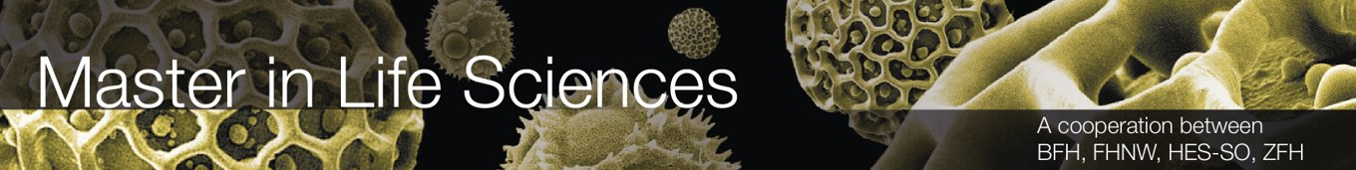

**Design of Biopharmaceutical Production Facilities**

By group 3:

Genilloud Franck, Khan Salman, Kölbener Christa,   
Kreuzer Jan, Kuleta Natalia Karolina, Lopez Sosa Alejandra,   
Memeti Nurdzane, Müller Benjamin-Anita, Näf Adrian, Nedic Maja,   
Nicollier Alexandre, Noël Jérémie, Pantelidis Alexandros,   
Pesen Pelin, Polini Elisa, Schürch Stefanie,   
Späne Philipp, Xaaji Yusuf, Zuković Dženneta

Master of Life Sciences

BP3

Date of Submission: 18.02.2022

Supervisors:

**Prof. Dr. Dieter Eibl**

**Lukas Hugentobler**

**Sven Kiesewetter**

**M. Sc. Fruhar Mozaffari**

Grüentalstrasse 14, 8820 Wädenswil

Abstract

In this report, the design of a biopharmaceutical production facility created for the BP3 module is described in detail. Based on the given user requirements specifications (URS), the plant has been designed to assure the production of four products (products A, B, C and D) based on hamster ovary (CHO) cell-derived monoclonal antibodies (mAb) in compliance with Swiss and US cGMP requirements. To fulfil the given URS, several calculations were made which showed that 72 batches with a production volume of 2000L were needed to reach the titer specified for the mAb production facility. Further calculations were made to determine the necessary seed, as well as production lines. To maximize the utilization of the plant, an occupancy list was created to and a staggered production process was selected. The results indicated that two inoculum seed lines, one 50L stainless steel bioreactor and one 200L single-use bioreactor, as well as three 2000L single-use bioreactors should be used to meet the goals set by the URS. Based on these assumptions, a four-story production facility was designed with a warehouse and an entrance attached to the main part of the building. Additionally, a height concept, a zoning concept, an and an area schedule were set and a 2- and 3- dimensional model of the building was created to visualize the facility including equipment. Lastly to operate the production facility, 85 full time equivalents will be necessary.

List of Abbreviations

|  |  |
| --- | --- |
| **Abbreviation** | **Meaning** |
| API | Active pharmaceutical ingredient |
| BDS | Bulk drug substance |
| BP | Buffer preparation |
| BSL | Bio safety level |
| cGMP | Current good manufacturing practice |
| CHO | Chinese hamster ovary |
| CNC | Controlled not classified |
| DCS | Distribution control |
| DS | Drug substance |
| DSP | Downstream process |
| E&L | Extractables and leachables |
| HVAC | Heating, Ventilation, and Air conditioning |
| mAb | Monoclonal antibody |
| MP | Media preparation |
| PCS | Process control safety |
| PW | Purified water |
| QC | Quality control |
| SAP | Systems, application & products in data processing |
| SCADA | Supervisory control and data acquisition |
| SUS | Single-use system |
| SUT | Single-use technology |
| URS | User requirement specification |
| USP | Upstream process |
| WFI | Water for injection |

Table of contents

1 Introduction 1

1.1 Single-use technology (SUT) 1

1.2 Application of Single-use technology 2

1.3 Group 3 organisation 2

2 Project Management 4

2.1 Occupancy list 4

2.2 Block flow diagram 8

2.3 Area schedule and room list 14

2.4 Height Concept 19

2.5 Staff requirement 23

3 Upstream Process 25

3.1 Introduction 25

3.2 Calculations 25

3.3 Plant on a page 27

3.4 HakoBio room concept 28

3.5 Size and functions of USP system 29

4 Downstream Process 34

4.1 Introduction 34

4.2 Plant on a page 34

4.3 Hako Bio room concept 35

4.4 Size and function of DSP systems 37

5 Media and Buffer preparation 42

5.1 Buffer estimation per batch 42

5.2 Plant on a page 43

5.3 HakoBio room concept of media and buffer preparation 46

5.4 Size and function of MP and BP systems 47

6 Quality Control 51

6.1 HakoBio room concept of the QC Laboratory 51

6.2 Size and functions of QC systems 52

7 Clean facility utilities 55

7.1 List of necessary clean and technical utilities 55

7.2 HVAC 55

7.3 Clean utilities 56

7.4 WFI, PW and clean steam 57

7.5 Technical utilities 60

7.6 Waste 61

7.7 Zone Concept Basement 61

8 References 65

List of figures 66

List of tables 67

List of equations 68

Appendix I

# Introduction

This report describes the conceptual design of a biopharmaceutical production facility based on a Chinese hamster ovary (CHO) cell-derived monoclonal antibody (mAb) manufacture. The report follows the user requirement specifications (URS) which is explained in detail in the appendix. The case study centres on a biopharmaceutical facility that will allow the production of four different mAbs and describes the planning of the entire production process, including upstream processing (USP) and down-stream processing (DSP). The facility tends to employ single-use systems (SUS) and technology (SUT) which allows for a better process by decreased contamination risk in a cheaper and more versatile process.

## Single-use technology (SUT)

As the name suggests, single use technology (SUT) deals with the use of materials that are disposed of after single use. SUT offers several advantages for a process and is being implemented in various areas of biologics and therapeutic vaccine production.

The usage of presterilized, gamma-irradiated equipment eliminates the need for clean-in-place (CIP) and steam-in-place (SIP) operations on the production containers. This prevents downtime through fast replacement of the equipment, as well as energy saving and a reduction of the solvent consumption. The cost of producing pure steam for SIP processes can be avoided, which leads to a significant cost reduction in a facility. (Parrish M. Galliher, 2018) Additionally, it minimizes the risk of cross-contamination between different products making it a good fit for facilities designed to produce multiple products. Furthermore, a cleaning validation is not required, also reducing work effort for the quality control (QC) department of a production site. Also, the turnover time can be reduced significantly the single use containers are preassembled. (Eibl & Eibl, 2019, Lopes, 2015)

Besides the many advantages SUT has to offer, there are also some major disadvantages hindering the use of SU-systems in some production processes. One of the major disadvantages are extractables and leachables (E&L). For instance, parts of the plastic materials of a SU-system could be released into the product, affecting its overall quality and safety. E&L events can occur under certain conditions, which is why the materials for a particular process should be carefully chosen, with the process conditions in mind (David J. Pollard, Alain Pralong, 2018). E&L substances must be reduced to a minimum and kept under a cerein threshold, as E&L leaching into a product line is always inevitable. E&L substances could have toxic effects depending on their toxicity and dose within a batch. Another disadvantage would be the material limitations, as there is no SU-bioreactor available with a volume over 6000L. This section still favours stainless steel bioreactors. Furthermore, the usage of the SU-equipment is restricted to one usage, after which the equipment will be disposed. Performing a production process with multiple SU-bioreactors throughout the year accumulates a large amount of plastic waste compared to the stainless-steel variant. (Eibl & Eibl, 2019)

Finally, it is also worth mentioning that by choosing a SUS for a biopharmaceutical production facility the dependence on the supplier of such systems increases dramatically. As a matter of fact, the equipment of different companies is in general incompatible. Therefore, it is almost impossible to switch the supplier. (Eibl & Eibl, 2019)

Table 1: Advantages and disadvantages of single-use technology (SUT) in production processes of biologics and other pharmaceutical products. (Eibl & Eibl, 2019)

|  |  |
| --- | --- |
| **Advantages** | **Disadvantages** |
| * No CIP- and SIP process needed * Lower labour and utility expanses * Preassembled * Lowering the risk of cross contamination * Quality control on the equipment goes to the provider of the SU-technology * Reduced facility footprint | * Release of E&L into the product * Up-scaling is limited trough material limitations * Higher waste production * Staff needed with SUT handling skills * Harder to automate the process * Restricted availability of disposable sensors * Dependence on supplier |

## Application of Single-use technology

As already mentioned, SUT finds its purpose in areas of efficient and sterile manufacturing processes, such as the production of antibodies against certain diseases or for cancer treatment medication. The easily replaceable bioreactors reduce time and manpower for the preparation or rehabilitation of a production line, as well as the control of cleanliness. The application of SUT also minimizes the duration of qualification procedures regarding new production facilities. This becomes particularly beneficial when time is a crucial factor to not only safe money but also lives, as it was the case in the development of a COVID-19 vaccination for instance (Gareth Macdonald, 2020).

## Group 3 organisation

The group number 3 was supervised by M.Sc. Fruhar Mozaffari. Subgroups were built to tackle the different task given, during the project. The assignment of the members to the different groups were conducted by the project management team. Besides the project management team, the additional subgroups were USP, DSP, media preparation (MP), as well as clean utilities and logistics. The whole organigram is illustrated in Figure 1. Each participant’s name is written to their respect subgroups as well as their affiliated school.

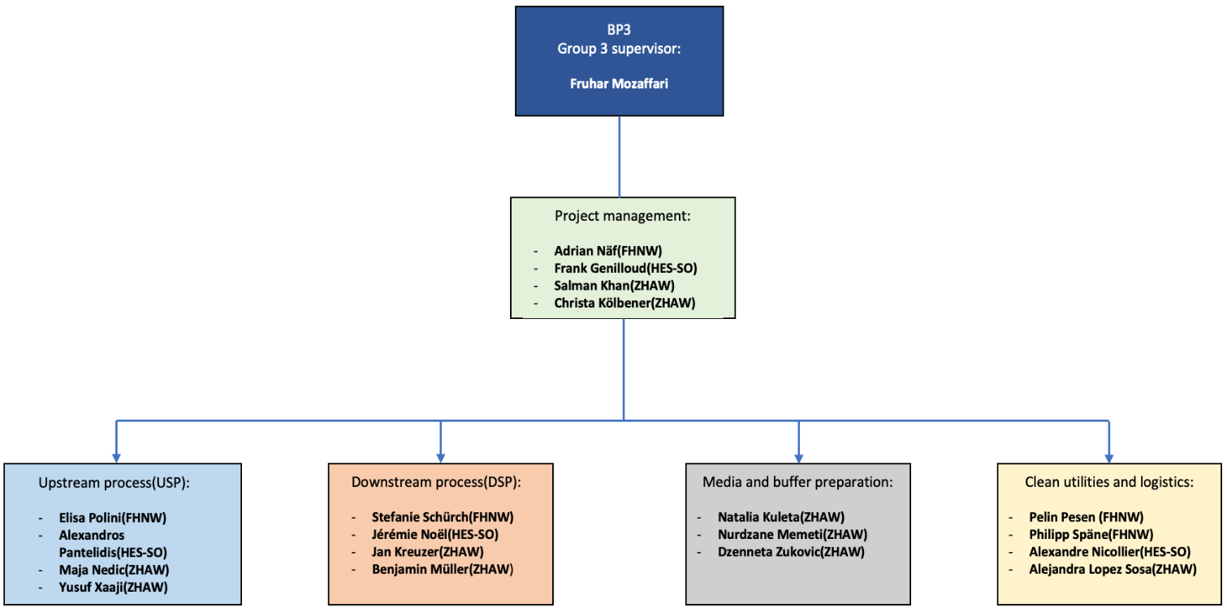

Figure 1: Organigram of group 3. The member of each subgroup are inside of each subgroup fields and their affiliated schools, from the MSLS-alliance, are written next to the respective names. The group supervisor is Fruhar Mozaffari.

# Project Management

This chapter focuses on aspects of production facility planning that falls within the scope of project management tasks.

## Occupancy list

To create an occupancy list fort the production facility, calculation had to be made for the products and the number of batches to reach a certain amount of product within a year’s time. In this case, the goal was the production of four different mAbs (labled as A, B, C and D). All the products shall be produced by the same CHO platform; thus, the same medium will be used. The amount of product (kg/year), titer (g/L) and yield (g/g) was specified by the URS and is listed in the   
Table 2. The calculation of the required batch amounts was summarized and has shown that 72 batches are required to achieve the amount of product specified by the URS. Parts of this calculation was used to create an occupancy list. More details and the used formula may be found in chapter 3.2.

Table 2: Requirements from the URS and calculations for the required batches regarding the four mAb products (A to D).

|  |  |  |  |  |  |  |
| --- | --- | --- | --- | --- | --- | --- |
|  | **Amount [kg/year]** | **Titer [g/L]** | **Yield [g/g]** | **Batch volume [L]** | **Batches/year** | **Batches/ year (rounded)** |
| **Product A** | 100 | 4 | 0.684 | 2000 | 18.274 | 19 |
| **Product B** | 70 | 3 | 0.706 | 2000 | 16.525 | 17 |
| **Product C** | 70 | 2 | 0.64 | 2000 | 27.343 | 28 |
| **Product D** | 40 | 4 | 0.64 | 2000 | 7.812 | 8 |
|  |  |  |  |  | **Total batches** | **72** |

Production should take place 320 days per year with 45 days off-time according to the URS. Additionally, the 72 batches were accounted to calculate the required seed and production lines as well as the number of bioreactors to meet the requirements and prevent unnecessary purchase of equipment. The results of the calculations are seen in the Table 3. The upstream process as a whole will take 24 days, which then will go over to the downstream process for additional four days. This displays the production time for one batch. To produce the 72 required batches, two inoculum production lines are needed, as well as three production bioreactors. The calculations will be explained in more detail in chapter 3.2 of the upstream process.

Table 3: Required production lines and estimated operational time of the production facility within a year.

|  |  |  |  |
| --- | --- | --- | --- |
| **Process step** | **Time [d]** | **Production lines / USP step** | **Production lines / USP step (rounded)** |
| **Inoculum production[2L]** | 7 | 2 | 2 |
| **Seed bioreactor 1 [20L]** | 3 | 1 | 1 |
| **Seed bioreactor 2 [200L]** | 3 | 1 | 1 |
| **Production bioreactor[2000L]** | 11 | 2.88 | 3 |
| **Down stream** | 4 |  | 1 |
| **Total production days** | 307 |  |  |

The occupancy list of the USP was meant to be used for the production of all 4 products (A to D) and is seen in Figure 2. It shows the planning for the first 34 days of production. A staggered production process was chosen to maximize facility utilisation. The production process consists of two inoculum seeds, as previously mentioned. The whole process starts with the inoculation of the first inoculum seed reactor for 7 days. After 4 days the second inoculum line will be started to perform a staggered process. After the 7 days of inoculum production, the inoculum will be transferred into the first seed reactor, where the cell culture will be cultivated in a 50 L bioreactor for three days. Afterwards, the cell culture will be moved to the second seed reactor for further cultivation. For the second seed a 200 L bioreactor will be used for another three days of cultivation. The last station during UP will be in one of the three 2000L production bioreactor, where the main antibody production will take place. The production lasts for 7 days, making it a total of 24 days to produce one batch. Full utilization of the facility will be achieved on day 22 of upstream process. After every end of a production step a changeover will be performed for material and cell culture transfer, cleaning of the equipment and/or replacement of the SUT equipment. The changeover is marked in orange. A rough overview of the downstream process is shown in the last part of the figure. This should give an idea of how much time is needed until one whole process is finished.

After the USP, the DSP will take place. The whole DSP process lasts for four days (rounded) after every end of an upstream batch. Figure 3 shows every step performed during the downstream process with the needed time to perform a step-in hour (rounded) and in what kind of room it will be performed (V+ or V-). Ten purification steps will be performed for the downstream process to be finished and are as follows: step 1 protein capture for 6 hours, step 2 virus inactivation for 7 hours, step 3 depth end filtration for 4 hours, step 4 cation exchange chromatography (CIEX) for 11 hours, step 5 pH-adjustment for 25 hours, step 6 anion exchange chromatography (AIEX) for 9 hours and step 7 nanofiltration for 17 hours. Step 7 will be the last step of the process which will be performed in a room with V+ classification. After step 7 the product will be transported in a room with V- classification where step 8 diafiltration/ultrafiltration will be performed for 13 hours. For step 9 and 10 a 0.2 µm filtration will be done for 4 hours following the bulk filling and freezing of the product, which will take 2 hours.

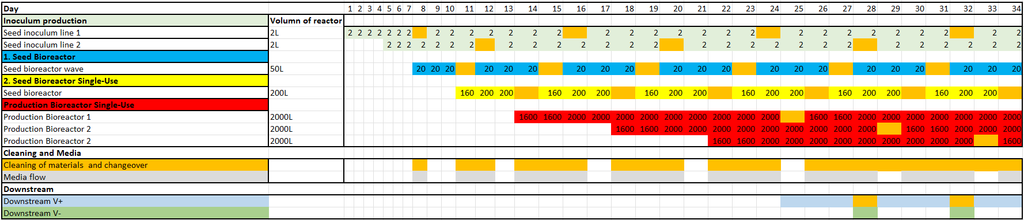

Figure 2: Occupany list of USP, DSP with media and buffer flow.

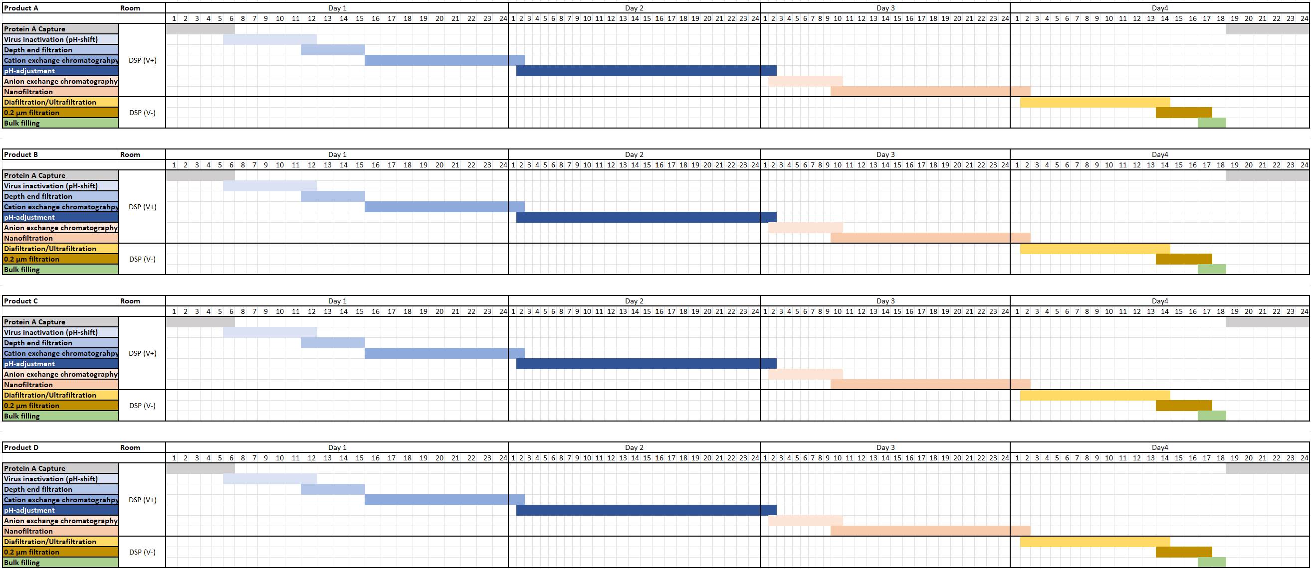

Figure 3: Occupancy list specific for DSP. Every step, which will be conducted is listed, with the estimated time in hours to perform the downstream steps.

## Block flow diagram

The whole product process may be displayed in a block flow diagram. This allows to show the volumes, concentrations and flows, in a step-by-step illustration. For each product a block flow diagram was made, showing the USP and the DSP of the respective product as well as the used equipment in the respective steps and in or outflow of media and buffer. The block flow diagram covers the same steps that were already roughly described in the chapter 2.1 through the occupancy list. The difference in each block flow diagram is the titer of each product.

The block flow diagram in Figure 4 is for the product A. Product A has a titer of 4 g/L. For product B the titer is set at 3 g/L and the block flow diagram is seen in Figure 5. Figure 6 shows the block flow diagram of product C with a titer of 2 g/L and Figure 7 is for the product D with a titer of 4 g/L.

The first step is the inoculum production with a starting volume of 2 L for the first passage. The inoculum production will be performed in 2L shake flasks. After two days the second passage will be performed with additional two days of cultivation. Afterwards a third passage will be performed with 3 days cultivation, marking it the last step of the inoculum production. The second step will be performed in a 50 L seed bioreactor with 2L of the cell culture from the previous step and start volume of 16 L. In addition, 4L of medium will be added during the three days cultivation. The 20L of cell culture will then be transferred into a 200L STR seed bioreactor for the third step. Cultivation will be performed in this reactor for 3 days, with a starting volume of 160 L. On day two of the cultivation, 40 L of feed medium will be added to the process. Step 4 will take place in a 2000 L STR seed bioreactor, for the production of the mAbs. The working volume in this step will start with 1600 L, which also includes the 200L of inoculum from the previous step. Another 400L of feed medium will be added to the process on day 3. The process continues for another 8 days, summing it up to 11 days of cell cultivation for producing the desired product. Afterwards the harvested product will be transported to the DSP for purification, marking the harvest as the last step of the USP part.

Only one DSP line is needed for the purification of all four products, since the sequential USP approach provides a new batch each 3.7 days and the total DSP time is 3.8 days. By temporally separating the processes, any contamination between products is avoided. For the first chromatography step (protein A capture) the material is introduced into a ÄKTA™ ready XL system, which is flushed and washed by different buffers provided directly from the buffer storage suites over an aseptic connection to a buffer management system. The eluted and purified product is collected in two 2000 L tanks. The material is then aseptically connected to an Allegro™ MVP system for virus inactivation, which is also tied to the buffer management system. The same Allegro™ MVP system is used to pump the virus inactivated product through three connected depth filters. The filtrate is collected in a 2000L and 2500L tank, which are subsequentially transported with a drive unit to a second ÄKTA™ ready XL system for cation exchange chromatography (CIEX). The purified product is eluted into a 2000 L tank and transported to a second Allegro™ MVP system for pH adjustment. This step is performed directly in the stirrable 2000 L tank and with buffers provided from the buffer suites in totes. This tank is then brought to a third ÄKTA™ ready XL system for anion exchange chromatography (AIEX). The eluted and purified product is collected in a 2000L tank. Both, CIEX and AIEX ÄKTA systems are managed by one buffer management system. The nanofiltration step is performed on the same Allegro™ MVP system as the pH adjustment step, to which two nanofiltration capsules must be installed. The virus filtered product is collected in a 2000L tank, which is ready to be transported to the ‘DSP V-‘ room.

Once the product arrives in the viral free zone, it is further processed in a fully automated centrasette TFF system, which is also supplied with buffer by a buffer management system linked to the adjacent buffer storage suites. The ultra- and diafiltrated material is directly connected to one depth filter and then collected in a 500 L tote. The purified bulk material is filled and transported by trolley to the DSP freezing room and finally to the storage room.

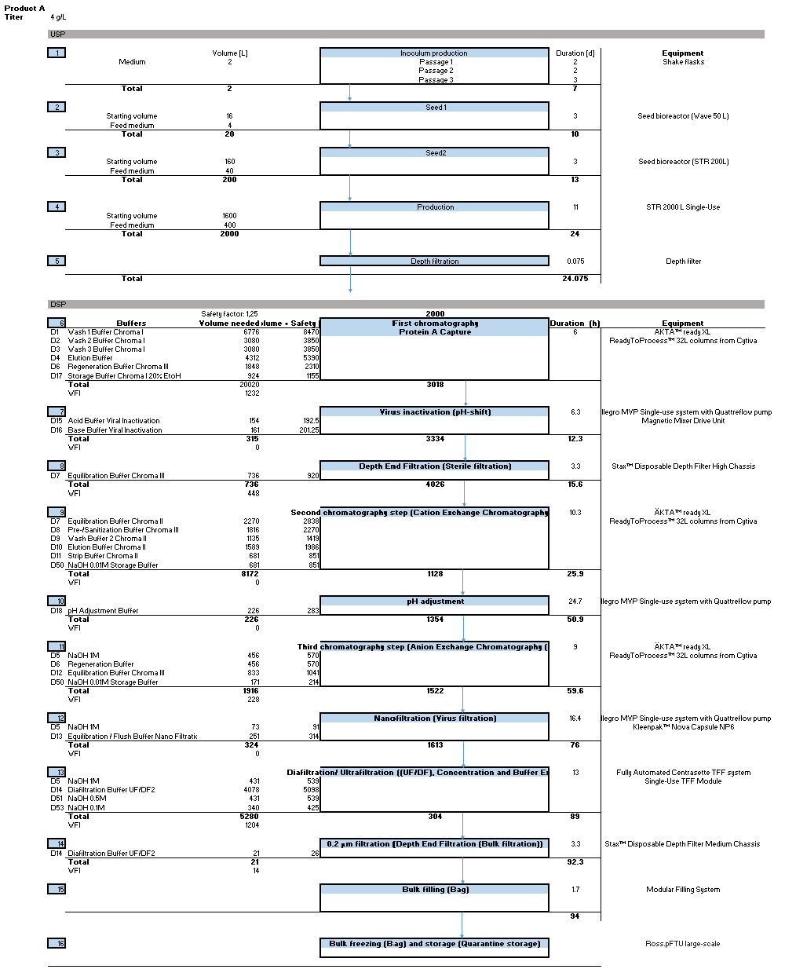

Figure 4: Block flow diagram of product A.

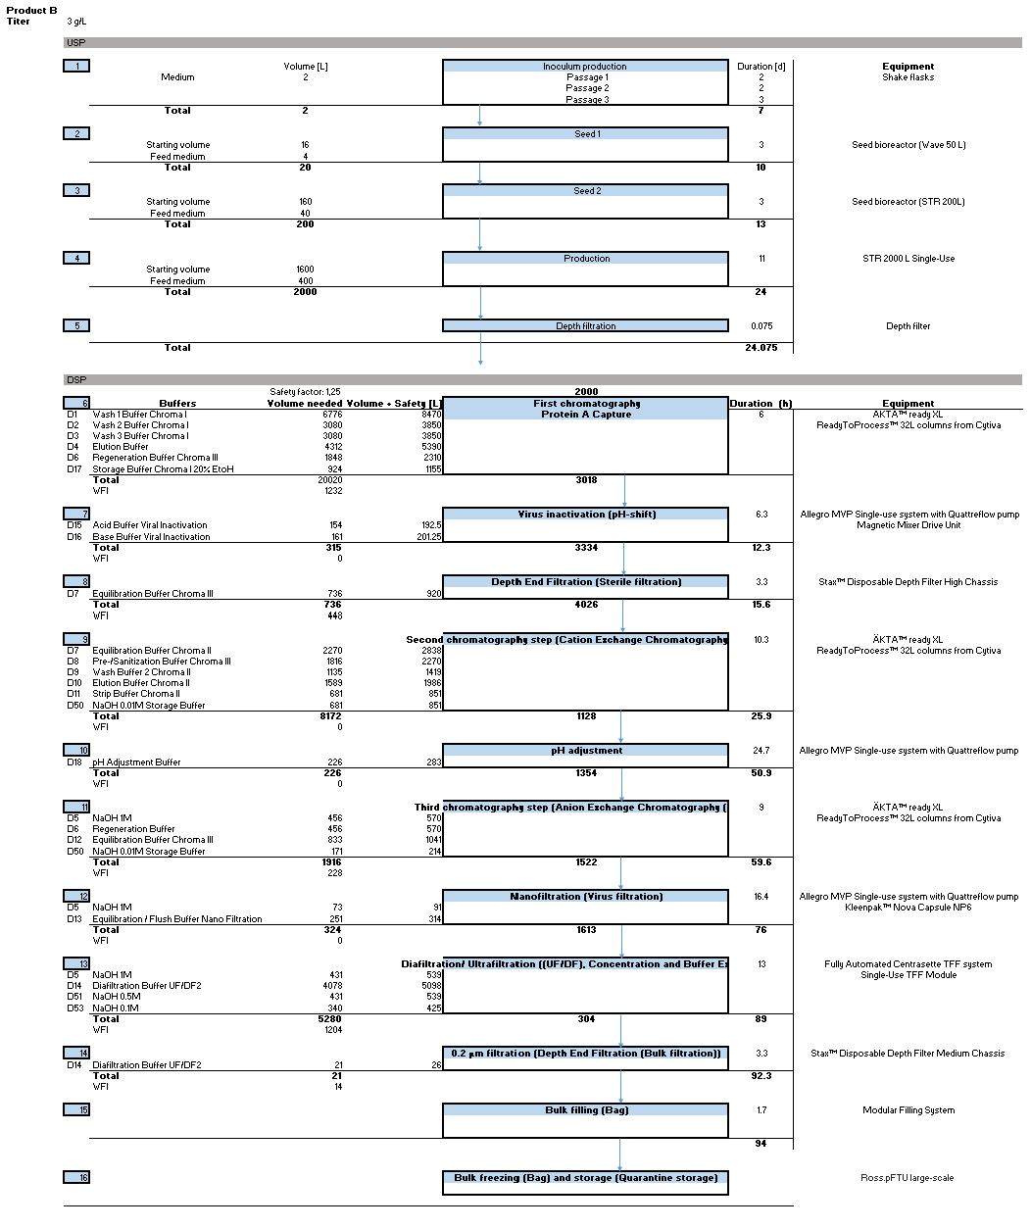

Figure 5: Block flow diagram of product B.

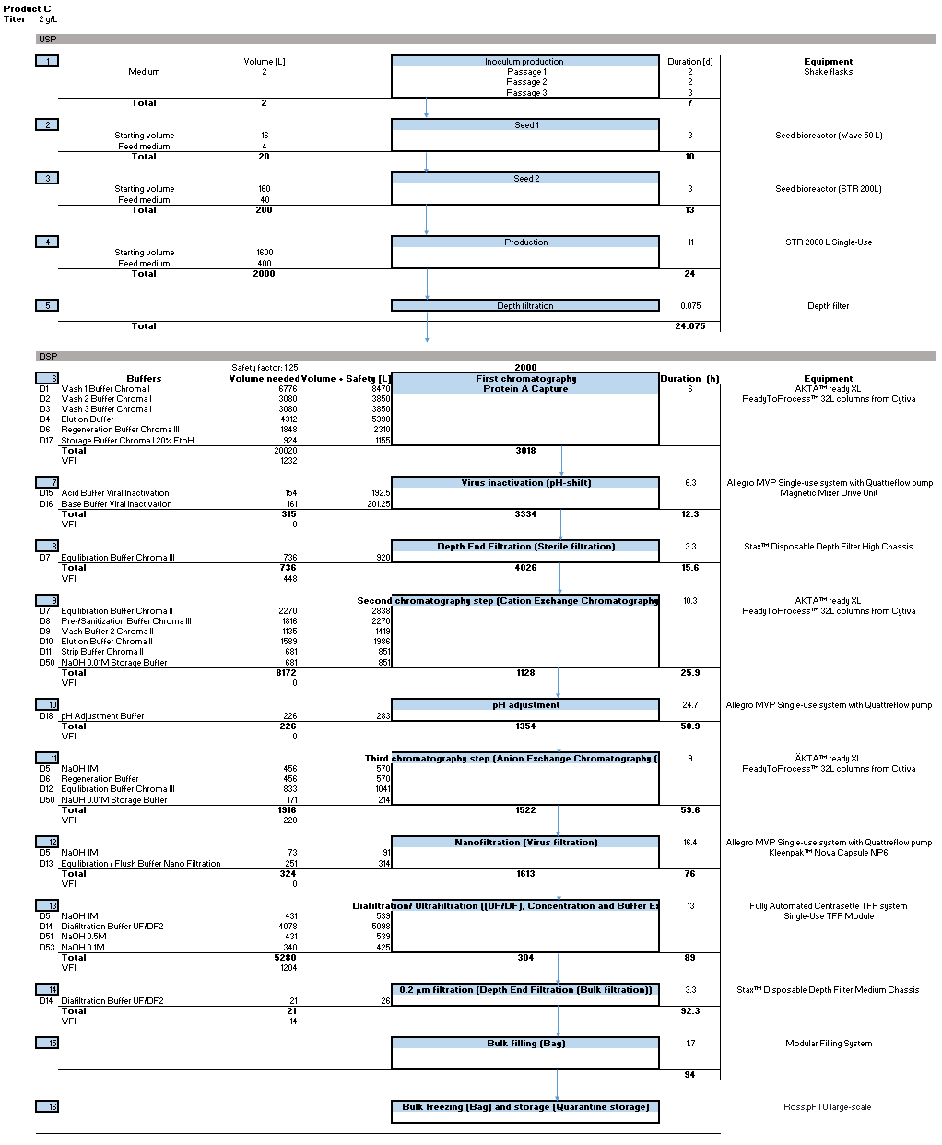

Figure 6: Block flow diagram of product C.

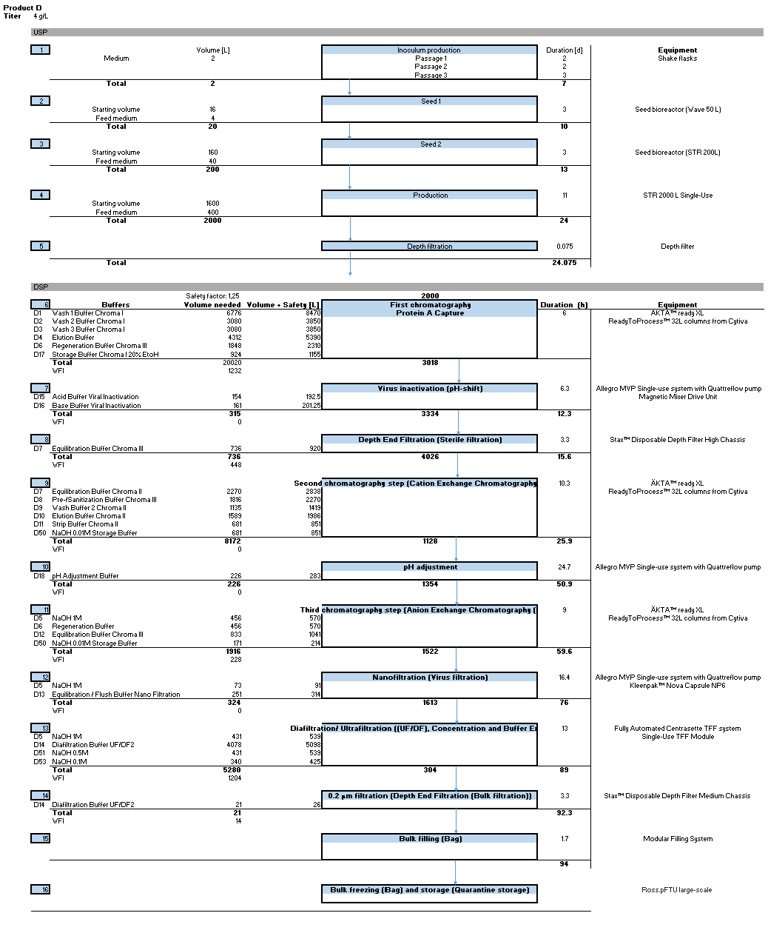

Figure 7: Block flow diagram of product D.

## Area schedule and room list

A HakoBio drawing of the production facility was used to estimate the area of every room. Table 4 shows a detailed list of every room, sorted by area.

Table 4: Area schedule and room list

| **Area** | **Room** | **BSL** | **Hygienic zone** | **Level** | **Area [m2]** | **Room height [m]** | **Room volume [m3]** | **Air exchange rate [h-1]** | **Airflow [m3/hour]** |
| --- | --- | --- | --- | --- | --- | --- | --- | --- | --- |
| Media | Medium preparation | none | D | Ground floor | 28 | 3 | 83 | 20 | 1660 |
| Medium & feed preparation | none | D | Ground floor | 41 | 3 | 122 | 20 | 2440 |
| Buffer preparation & storage | none | D | Ground floor | 187 | 4 | 560 | 20 | 11200 |
| Medium cold storage | none | D | Ground floor | 49 | 3 | 146 | 20 | 2920 |
| USP | Personnel Airlock Inoculation Lab | 1 | C | Ground floor | 6 | 3 | 17 | 30 | 510 |
| Inoculum Production lab | 1 | C | Ground floor | 40 | 3 | 119 | 30 | 3570 |
| Cell expansion, Production | 1 | D | Ground floor | 145 | 3 | 434 | 20 | 8680 |
| Harvest | 1 | D | Ground floor | 30 | 3 | 91 | 20 | 1820 |
| Corridor | none | D | Ground floor | 36 | 3 | 107 | 20 | 2140 |
| Corridor | none | D | Ground floor | 36 | 3 | 109 | 20 | 2180 |
| Corridor | none | CNC | Ground floor | 34 | 3 | 101 | 10 | 1010 |
| DSP | Personnel Airlock USP -DSP V+ | none | C | Ground floor | 28 | 3 | 83 | 30 | 2490 |
| Personnel Airlock DSP V- - freezing | none | C | Ground floor | 18 | 3 | 53 | 30 | 1590 |
| Personnel Airlock DSP V- - freezing | none | D | Ground floor | 8 | 3 | 25 | 20 | 500 |
| Personnel Airlock DSP V+ - Corridor | none | C | Ground floor | 6 | 3 | 17 | 30 | 510 |
| Personnel Airlock DSP V+ - Corridor | none | D | Ground floor | 6 | 3 | 17 | 20 | 340 |
| Material Airlock USP QC -DSP V+ | none | C | Ground floor | 14 | 3 | 43 | 30 | 1290 |
| Material Airlock Buffer storage - DSP V+ | none | C | Ground floor | 6 | 3 | 17 | 30 | 510 |
| Material Airlock DSP V- - Freezing | none | C | Ground floor | 6 | 3 | 17 | 30 | 510 |
| Material Airlock DSP V- - Freezing | none | D | Ground floor | 8 | 3 | 25 | 20 | 500 |
| DSP room V+ | none | C | Ground floor | 209 | 3 | 627 | 30 | 18810 |
| DSP room V- | none | C | Ground floor | 68 | 3 | 203 | 30 | 6090 |
| DSP cleaning | none | D | Ground floor | 25 | 3 | 76 | 20 | 1520 |
| DSP freezing room | none | CNC | Ground floor | 27 | 3 | 82 | 10 | 820 |
| DSP storage room | none | CNC | Ground floor | 39 | 3 | 116 | 10 | 1160 |
| QK | QC Lab | none | CNC | Ground floor | 70 | 3 | 210 | 10 | 2100 |
| Utilities | HVAC | none | NC | 2nd floor | * | 5 | * | 5 | * |
| Ambient Heating & Cooling | none | NC | 2nd floor | * | 5 | * | 5 | * |
| Waste treatment | none | NC | Basement | * | 3 | * | 5 | * |
| Portable Water and Purified Water | none | NC | Basement | * | 3 | * | 5 | * |
| WFI/Steam Production | none | NC | Basement | * | 3 | * | 5 | * |
| Clean compressed Air | none | NC | Outside | 10 | 4 | 40 | Outside | Outside |
| Process Gases | none | NC | Outside | 30 | 4 | 120 | Outside | Outside |
| Emergency Generators | none | NC | Basement | * | 3 | * | 5 | * |
|  |  |  |  |  |  |  |  |  |  |
| Ware-house | Warehouse | none | NC | Ground floor | 500 | 7 | 3500 | 5 | 17’500 |
| Facility Management | Reception | none | NC | Ground floor | * | 5 | * | 5 | * |
| Offices | none | NC | 1st floor | * | 5 | * | 5 | * |
| Cafeteria | none | NC | 1st floor | * | 5 | * | 5 | * |
| Toilets Men | none | NC | 1st floor | * | 5 | * | 5 | * |
| Toilets Women | none | NC | 1st floor | * | 5 | * | 5 | * |
| Stairs | none | NC | 1st floor | * | 5 | * | 5 | * |
| Elevator | none | NC | 1st floor | * | 5 | * | 5 | * |
| Data Storage | none | NC | Basement | * | 5 | * | 5 | * |

* values are not precisely defined

### Biosafety level (BSL)

Recombinant organisms produced by genetic manipulation are considered biological hazards if they can survive in the environment or in living organisms and pose a health risk (Miller & Bergmann, 1993). The safe handling of infectious organisms or biological materials that may harbor them, including the safe handling of recombinant and synthetic DNA (rDNA) materials, is regulated by various national institutional committees („Appendix B – Large Scale Biosafety Guidelines“, 2010). In the United States, for example, this is administered by the Center for Disease Control (CDC), which has defined safety levels from the lowest level 1 (BSL-1) to the highest level 4 (BSL-4). The same biosafety levels are established in the European Union (Council Directive 90/679/EEC, 1990). In the URS, the production site is defined as BSL-2. Level 2 is applied for work with agents with moderate hazard potential. The following procedures / practices are prescribed (Joseph, 2018):

* Standard cGMP / microbiological practices (including gloves, protective clothing, eye protection and other personal protective equipment (PPE)) as for BSL-1.
* Personnel are trained in handling pathogenic agents and are guided by competent scientists.
* Restricted access to active work areas while working
* Extreme precautions are taken when handling contaminated sharps
* Procedures that may generate infectious aerosols or splashes are performed in biological safety cabinets or other physical containment facilities

### Area classification

Bioproduction facilities are usually designed according to a shell-type control concept. Thereby, the most critical process activities are performed in clean rooms with a higher cleanliness standard, which are surrounded by areas of lower classifications. Control of the environment within a facility is basically divided into three degrees:

* Not classified (NC)
* Controlled-Non-Classified (CNC) rooms, where temperature, pressure and humidity are monitored. CNC rooms are generally acceptable for closed process systems. In this case, the product is protected by the system operation and is therefore independent of the room environment.
* Classified rooms, where the air is validated to a certain level of purity, so-called "clean rooms". Cleanliness is defined by the number of particles in a volume of air and rooms are divided into classes of A, B, C and D, with A being the cleanest. Clean rooms are relevant for open processes, where the room environment is part of the product protection strategy (Joseph, 2018).

The classification of the given rooms can be found in the area schedule   
Table 4 and in Figure 8, Figure 9 and Figure 10.

### Zone Concept

Figure 8, Figure 9 and Figure 10 present a schematic view of the zone concept for the production site. In these schemes, the dimensions are not representative to the real production facility. The zone concept was designed in a way to avoid cross-contamination when moving the product to and from the different production steps. The different colours of the rooms correspond to their hygiene zones, with D-class in yellow, C-class in green, Controlled-not-Classified (CNC) in grey and non-classified (NC) in white. The grey-yellow boxes represent the airlocks, which are necessary for material and personnel to change rooms with different hygiene classes safely. The personnel movements are depicted with blue arrows, the material with red arrows, the waste in green and finally the product flow is represented by purple arrows.

The following Figure 8Figure 8 depicts the zone concept of the actual biopharmaceutical production facility, as well as its extensions consisting of the warehouse and the restaurant/cafeteria located on the ground floor. It is shown that only DSP V-/+ and the inoculum lab are specified as class C. The administration, quality control, DSP freezing and storage are CNC. On the other hand, the cleaning room, Media/Buffer preparation and storage, as well as the USP production and harvest operate under class D requirements.

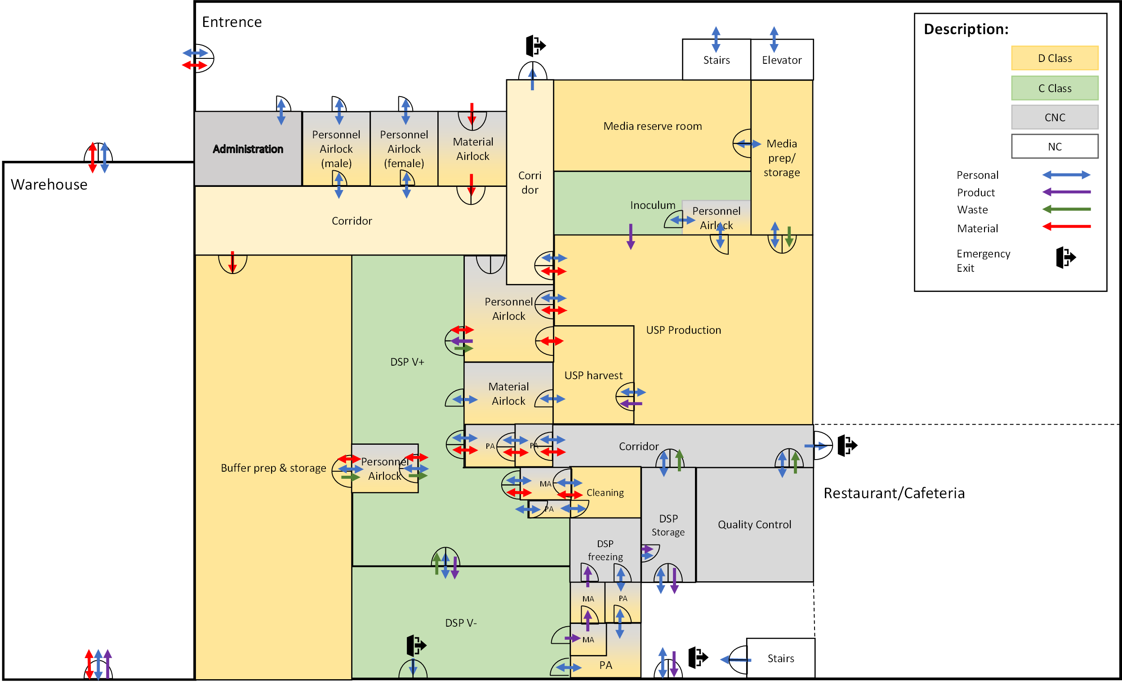

Figure 8: Zone concept of the biopharmaceutical production facility regarding the ground floor.

Employees who enter the building may reach the specified area through a personnel airlock. Material that is required for production can either be brought into the zone D by passing the material airlock or directly from the warehouse. To reach the more strictly classified zone C both material and personnel must cross another airlock.

In the Figure 9 the zone concept of the 1st floor of the main building is visible. As there are no critical processes performed here, it makes no sense to apply a classified zone on this floor. Furthermore, the operation under classified areas causes higher costs and the additional clothing maybe uncomfortable for the employees. Therefore, the entire floor is a non-classified area.

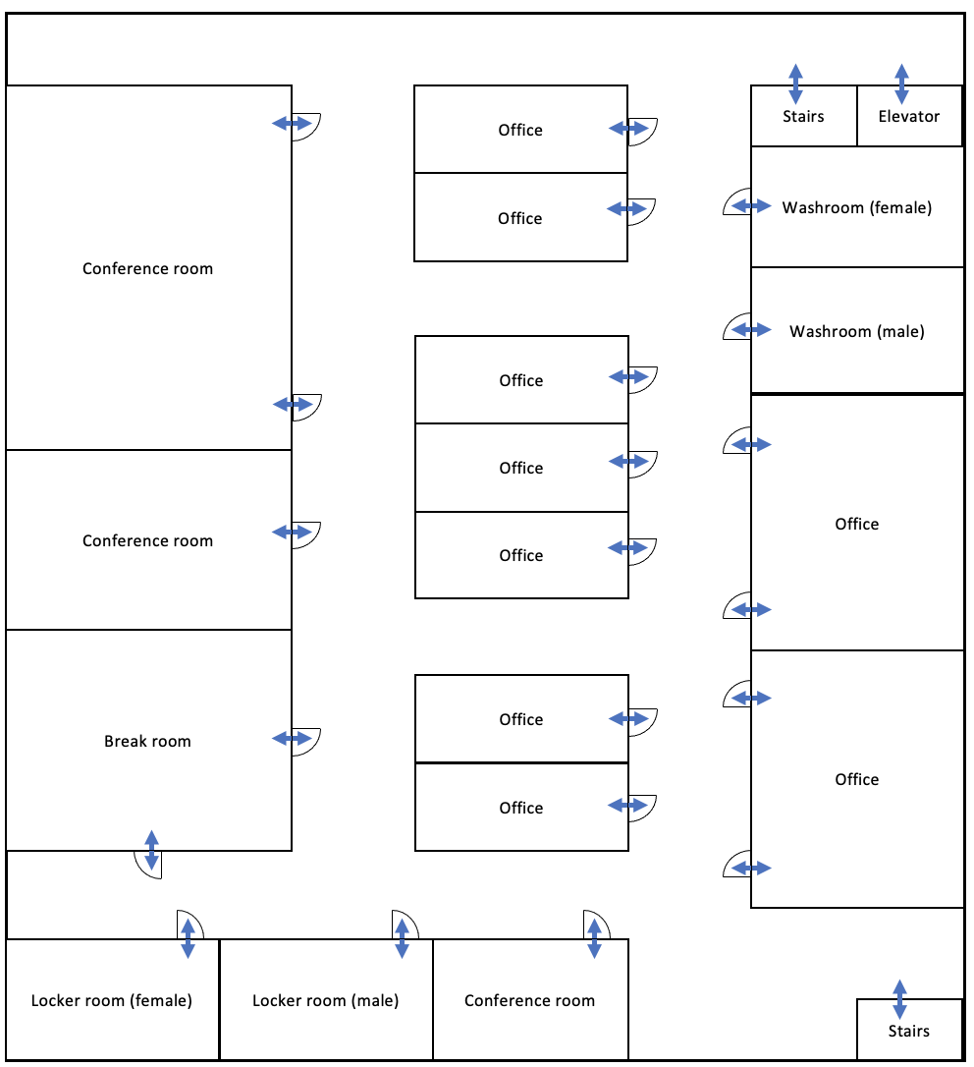

Figure 9: Zone concept of the 1st floor. Mostly offices and conference rooms are located on this floor.

The zone concept of the 2nd floor is shown in the Figure 10. On this level the HVAC system is installed. Since no product critical process steps are executed here either, the entire floor is a NC area.

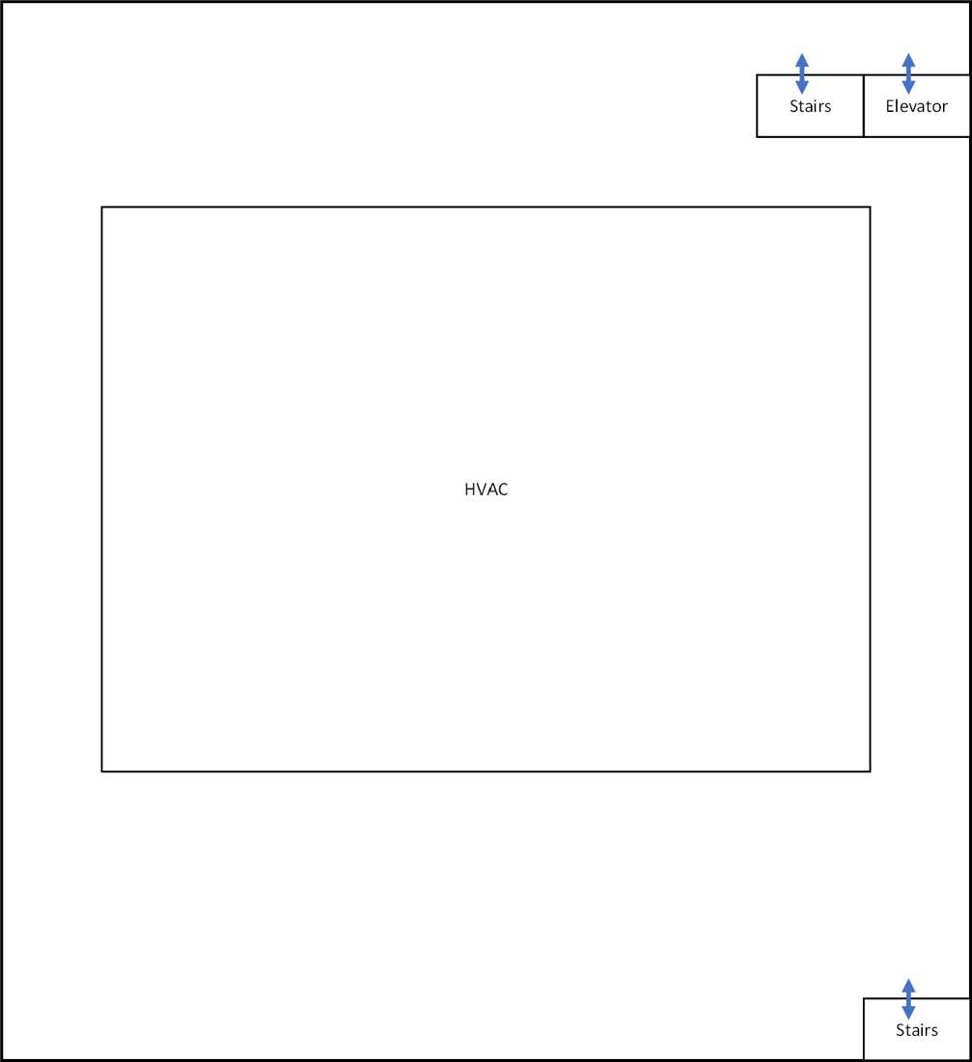

Figure 10: Zone concept of the 2nd floor. This level contains the HVAC system.

## Height Concept

The hight concept defines how many floors the production facility needs and the height of every specific floor. As it is shown in the Figure 11 production facility consists of 4 floors, a warehouse attached to the building and an entrance at the production floor (ground floor). The height of the floors was defined according to the necessary equipment that will be installed on them. The different heights are listed in the

Table 5.

Production of the different mAb products and their respective quality control will take place on the ground floor. The overall height of the production floor will be 3 meters with exception to the media- and buffer-preparation/storage room for the reason, that these sections have the highest containers in the production area. Additional crawl space for maintenance of the air ventilation system is implemented. The basement houses different utilities that a production facility needs to be fully functional and technical areas for data storage or power generators. Several areas were allocated for WFI-production, which will be used throughout the mAb production processes, as well as for containment and waste neutralisation. Power and emergency generators are also required to provide electricity to the whole facility in case of power outages. The first floor consists of offices for the employees and conference rooms. A height of 5 meters was determined for this floor to leave enough space for interior design ideas to build a pleasing atmosphere for the future employees. The second floor builds an additional area for technical utilities but is more specifically planed for air handling units (AHUs) and other HVAC utilities. Some of these devices are connected to production rooms through ventilation systems, to provide clean air. As already mentioned, the warehouse is attached on the sides of the building and will be used to store materials. Storage of the materials in shelves makes the work deployment of certain equipment more efficient and eases the overview of the inventory. A height of 7 meters will provide enough volume for the storage of all the single-use and reusable goods, as well as raw materials. Also attached to the main body of the building is the entrance. The entrance should also include a cafeteria and cantina for lunch breaks and after noon breaks, as well as giving the employees the possibility to have a breakfast. Keeping it near the production area will decrease non-productive time for the employees, due to the little distance to the break room.

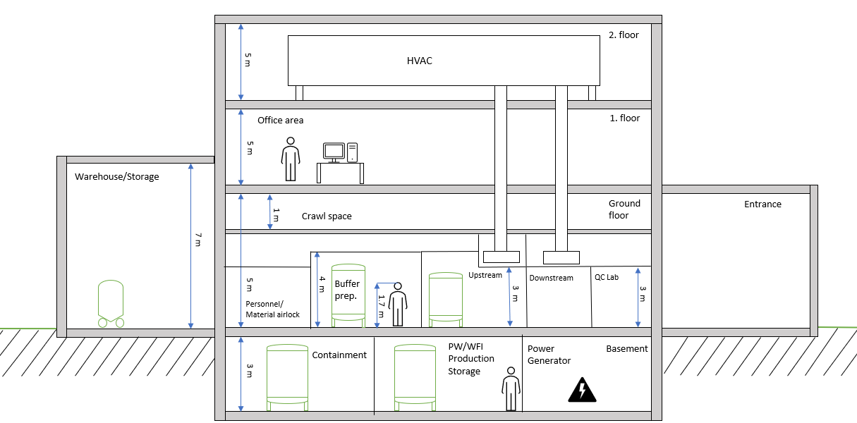

Figure 11: Height concept of the designed production facility for mAb production. The different floors, with their respective heights can be seen, as well as the heights of the attached buildings e.g., warehouse.

Table 5: Heights of the different rooms based on the height concept, in meters.

|  |  |
| --- | --- |
| **Room** | **Height [m]** |
| Basement | 3 |
| Personnel/Material airlock | 3 |
| Buffer Preparation | 4 |
| Upstream | 3 |
| Downstream | 3 |
| Warehouse Storage | 7 |
| Crawl space | 1 |
| Entrance | 5 |
| Office | 5 |
| HVAC room | 5 |

### 3D and 2D layout of the production area

With the program HakoBio a 3D layout of the production area, as well as the media and buffer preparation area were made. This is seen in the Figure 12. Dependent on the room classification an air lock needs to be crossed to get to another room. Therefore, a personal and a material airlock was inserted. For example, to enter the USP inoculum production (class C) from the USP production area (class D) an air lock must be crossed. This also applies for the transition from an USP area (mostly classification D) to DSP V+/- area (classification C).

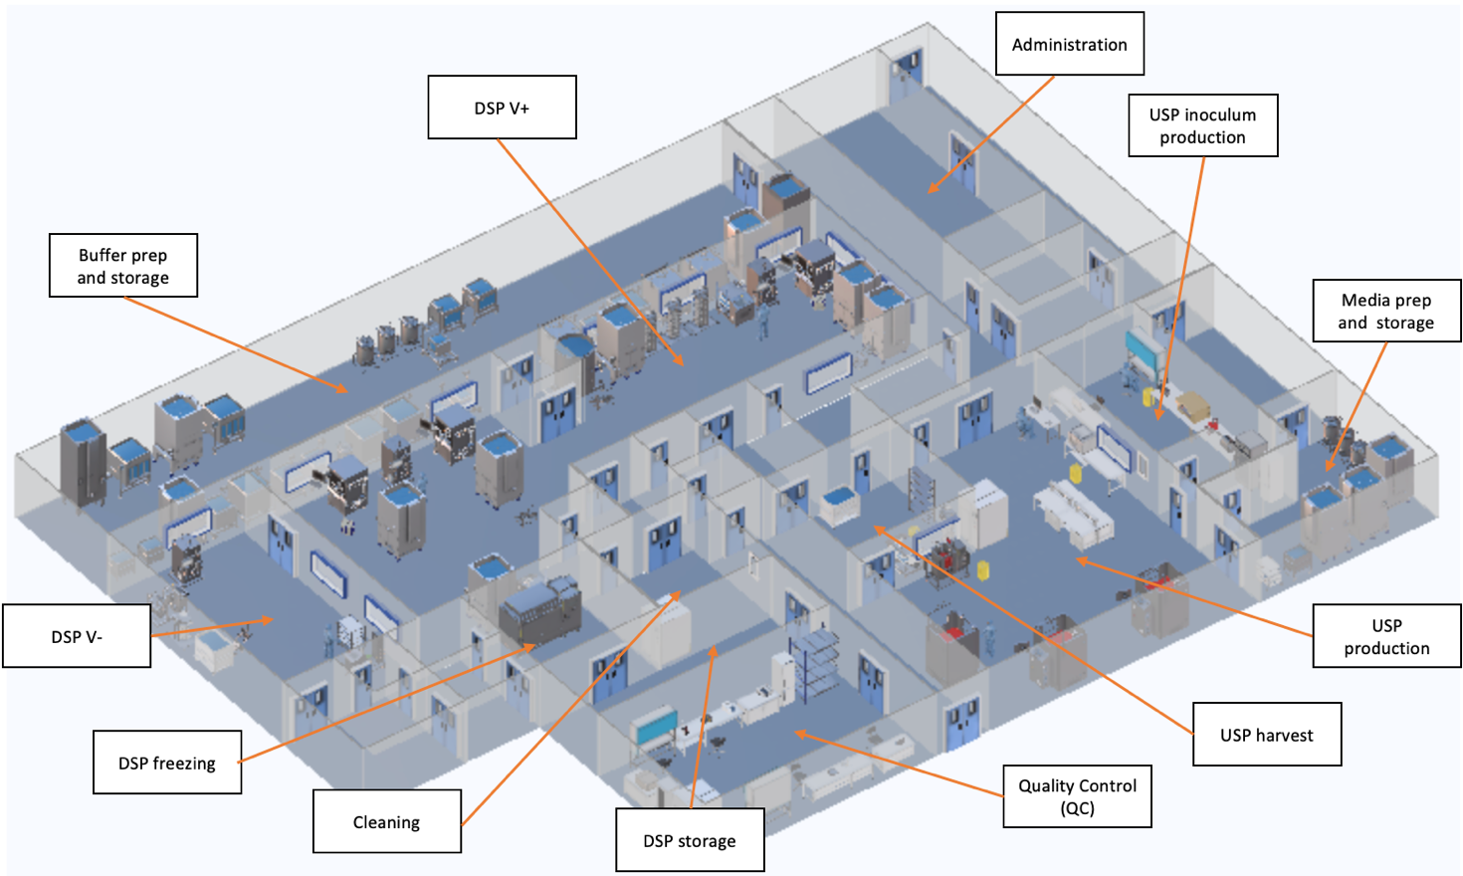

Figure 12: 3D layout of the production area made using the program HakoBio. The different room names are written in the respective blocks, pointing with an orange arrow to the location.

In Figure 13 a 2D layout of the production area is seen. The orange arrows indicate the production flow. Additionally, numbers were added indicating the different steps, which were taken until the final product is achieved. Step 1 starts with the inoculum production and the production ends with step 21, where the mAb product is stored. The whole process and the equipment will be explained in the USP (chapter 3) and DSP (chapter 4) chapters.

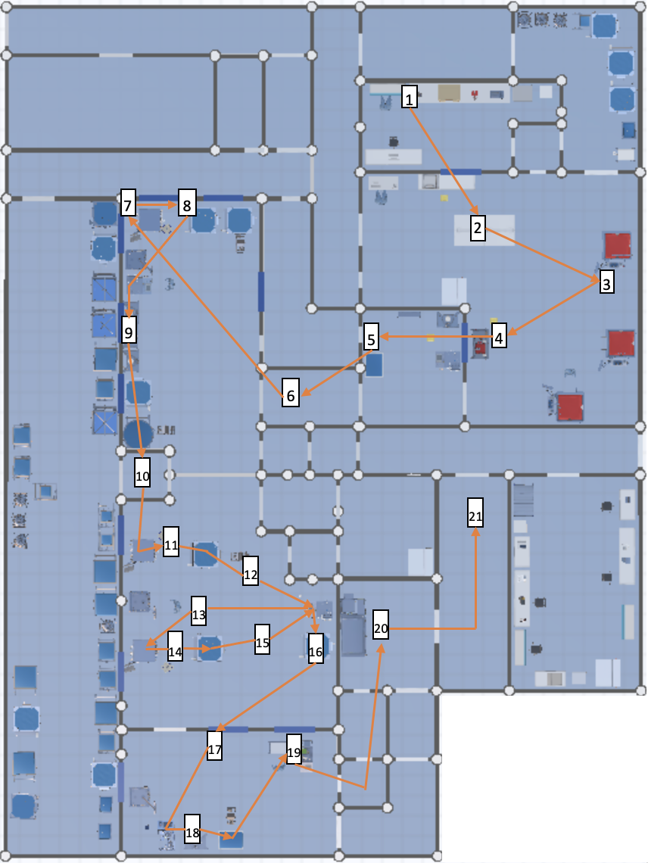

Figure 13: 2D layout of the production area made with the program HakoBio. The orange arrows indicate the product flow and the number in the blocks indicates the steps taken during the production.

## Staff requirement

The total number of Full Time Equivalents (FTE) in shift mode for each department of the production facility was calculated based on the required working days per week, the number of shifts and the number of FTE per shift following the Equation 1 below. The results are depicted in the   
Table 6.

Equation 1: Formula to calculate the required staff, dependent on the workdays, number of shifts and employees in an area per shift.

$$FTE=\frac{\left(\left(5⋅\frac{days}{week}\right) ⋅ number ofshifts ⋅\frac{FTE}{shift}\right)}{21}$$

In addition, the amount of FTE per area was determined by summing the FTE in shift mode, the FTE day team and the FTE manager. Thus, the number of employees that must be hired corresponds to a total of 84.6 FTE. Furthermore, the maximum of Full Time Equivalents, which are simultaneously at the facility is 51.

Table 6: FTE estimation in different areas of occupations, in the designed facility.

|  |  |  |  |  |  |  |  |
| --- | --- | --- | --- | --- | --- | --- | --- |
| **Area** | **Working days** | **Shifts** | **FTE per Shift** | **Total FTE (Shift)** | **FTE Day Team** | **FTE Manager** | **Total FTE** |
| USP | 7 | 2 | 3 | 10.0 | 1.0 | 0.5 | 11.5 |
| DSP | 7 | 3 | 3 | 15.0 | 1.0 | 0.5 | 16.5 |
| Buffer preparation | 5 | 1 | 2 | 2.4 | 0.5 | 0.5 | 3.4 |
| Media preparation | 5 | 1 | 2 | 2.4 | 0.5 | 0.5 | 3.4 |
| Clean utilities | 7 | 1 | 2.5 | 4.2 | 0.0 | 0.25 | 4.4 |
| Black utilities | 7 | 1 | 1.5 | 2.5 | 0.0 | 0.25 | 2.8 |
| Warehouse/logistics | 5 | 2 | 2 | 4.8 | 0.0 | 0.25 | 5.0 |
| Building Management | 5 | 1 | 2 | 2.4 | 1.0 | 0.25 | 3.6 |
| QA | 5 | 1 | 0 | 0.0 | 4.0 | 1.0 | 5.0 |
| QC | 7 | 3 | 2 | 10.0 | 0.0 | 1.0 | 11.0 |
| Process Development | 5 | 1 | 0 | 0.0 | 6.0 | 1.0 | 7.0 |
| Administration | 5 | 1 | 0 | 0.0 | 10.0 | 1.0 | 11.0 |
|  |  |  |  | Total FTE |  |  | 84.6 |
|  |  |  |  | Max. FTE simultaneously in Facility | | | 51 |

# Upstream Process

## Introduction

Engineered mammalian cells are used for the production of monoclonal antibody (mAb). The preliminary steps in their generation are comprised in Upstream Processing (USP). USP includes cell culture seed development, inoculum, bioreactor culturing and harvest (Joseph, 2018). The crucial aim of USP is to scale up the volume of culture systems up to several thousand litres, in order to produce kilograms of the desired mAb in a facility designed to reduce the risk of contamination.

The workflow for this case study is represented in Figure 14 and it can be summarized as follows.

The seed train is characterized by three passages performed in 7 days to obtain a final volume of 2 L in shake flask. Then the content of the 2 L shake flask is transferred into the 50 L wave bag bioreactor together with 14 L of basal medium and 4 L of feed medium to reach a final volume of 20 L. After 3 days cells are transferred into the seed STR 200 bioreactor with 140 L of basal medium, on the second day of cultivation in this bioreactor 40 L of feed medium are added. Cells are recollected 3 days after start. At this point cells are introduced in STR 2000 bioreactor, and 1400 L of basal medium are added. Feeding is started 3 days after the beginning of production with 400 L of medium to achieve a final volume of 2000 L. According to our calculations (refer to chapter 3.2) three STR 2000 bioreactors are necessary to produce 72 batches per year. Once completed the production phase, cells are harvested by a filtration step with depth filter before sending the product to the downstream processing (Schirmer et al., 2021).

## Calculations

To determine the number of batches that will be needed to achieve the required production, the following equations were used (Equation 2):

Equation 2: Total amount of batches per year needed, of all the four mAb products (A to D), to fulfill the URS of the production facility.

$$Total required batches per year \left[\frac{batch}{year}\right]=\sum{\frac{Required amount per year \left[\frac{kg}{year}\right]}{Amount of product per batch \left[\frac{kg}{batch}\right]}}=$$

$$\frac{100 \left[\frac{kg}{year}\right]}{5.472 \left[\frac{kg}{batch}\right]}+\frac{70 \left[\frac{kg}{year}\right]}{4.236 \left[\frac{kg}{batch}\right]}+\frac{70 \left[\frac{kg}{year}\right]}{2.56 \left[\frac{kg}{batch}\right]}+\frac{40 \left[\frac{kg}{year}\right]}{4.12\left[\frac{kg}{batch}\right]}=19+17+28+8=72 \left[\frac{batch}{year}\right]$$

Knowing the number of batches needed, the number of batches that can be done (in one year) using one bioreactor has been calculated as seen in Equation 3:

Equation 3: Calculation for number of batches needed to produce the defined amount of mAb product A according to the USR, for a year.

$$Number of batches \left[-\right]=\frac{operational readiness \left[d\right] }{length of production in bioreactor\left[d\right]}=\frac{320 d -13 d}{(11+1) d}=25.58 ≈25$$

Where the operational readiness and the production time in the bioreactor is given by the Operational requirements in the URS document. One day has been added to the production time for cleaning purposes. It is then possible to calculate the number of bioreactor lines that will be necessary to reach the yearly production rate with Equation 4:

Equation 4: Calculation for the number of required production bioreactors.

$$Number of bioreactor lines\left[-\right]=\frac{Total required batches per year \left[\frac{batch}{year}\right]}{batches per year per reactor \left[batch\right]}=\frac{72}{25 }=2.88 ≈3$$

With the number of bioreactor lines, the minimum number of seed trains can be calculated as follows (Equation 5):

Equation 5: Calculation for the number of required seed lines.

$$Number of seed lines\left[-\right]=\frac{number of bioreactor lines\left[-\right]*length of a seeding process \left[d\right]}{length of production in bioreactor\left[d\right]}=\frac{3 *(3+1) d}{(11+1) d}=1$$

In this calculation, an additional day has been added to each step to account for the cleaning and preparations of the utilities. Only one seed line will be necessary to meet the production requirements.

Finally, the number of inoculum lines can be determined with the following formula (Equation 6):

Equation 6: Calculation for the number of required inoculum lines.

$$Number of inoculum lines\left[-\right]=\frac{number of bioreactor lines\left[-\right]*length of an inoculum process \left[d\right]}{length of production in bioreactor\left[d\right]}=\frac{3 *(7+1) d}{(11+1) d}=2$$

An additional day has also been used in each step to account for the cleaning and preparation of the utilities. In this case, two inoculum lines will be required. These results are the basis on which the rest of the production plan will be designed.

## Plant on a page

For the upstream process, a plant on a page was designed (refer to Figure 14). The main goal is to get an overview over the whole process. Also, the necessary equipment can be listed that way. The plant on a page consists of four steps: the inoculum step, seed 1, seed 2, the production step and a depth filtration step. The detailed description for each step can be found in chapter 3.1. As mentioned, three production lines are planned to be used therefore three STR 2000 bioreactors were added. Only the lines of one production reactor were drawn to avoid clutter. The media and feed container are shown, however those are to be transferred from the media preparation room.

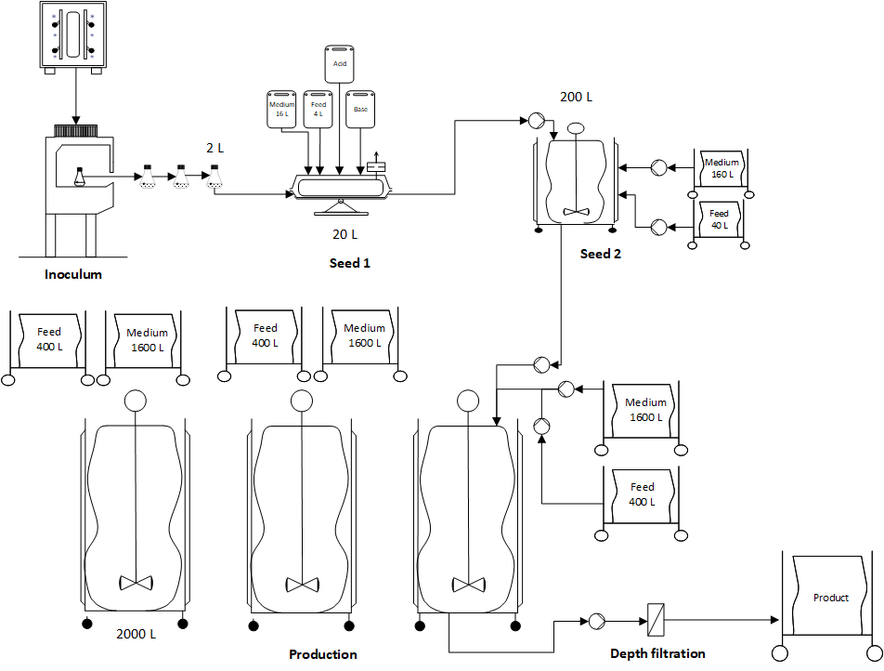

Figure 14: USP Plant on a page

## HakoBio room concept

For the simulation and visualization of the room concept, the HakoBio software from PALL Corporation was used. The images are shown as 3D visualization and represent the inoculum room (1), seeding (2) and production (3) room, followed by the transfer (4) to the harvest room and depth filtration process (5). Finally, the production is transferred further to the DSP (6) Lastly transferring the production further to the DSP (6) (Figure 15). The devices and production equipment used for this design are described and shown in chapter 3.5. The production process starts in the inoculation room, in cleanliness class C. Followed by a material and personnel airlock, the seeding and USP process are in the same room. This room is categorized as cleanliness class D. Hereby the process is divided into the seeding train and production process. Last of all, the harvesting is performed in a separate room, also classified as class D.

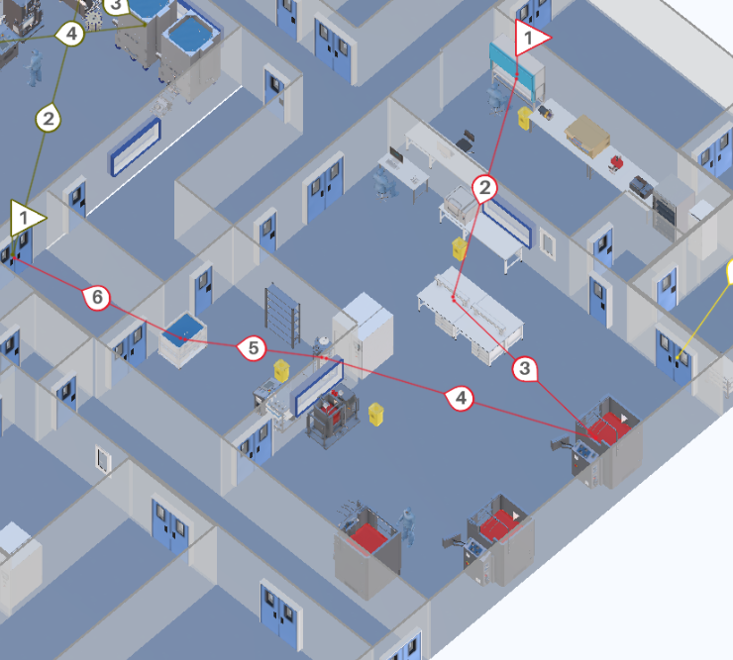

Figure 15: 3D layout of the USP process (created with HakoBio), The process flow is shown with the red process line, starting in the inoculum room (1), seeding (2) and production (3) room, followed by the transfer (4) to the harvest room (5), where the depth filtration is performed. Lastly transferring the production further to the DSP (6).

## Size and functions of USP system

In this paragraph, Table 7 shows the equipment required for USP in mAb production. The table highlights the types of material, their quantity, power consumption and size. The analysis of the equipment needed, and their size is crucial for the biopharmaceutical facility design.

Table 7: Equipment for USP in mAb production

|  |  |  |  |  |  |  |  |
| --- | --- | --- | --- | --- | --- | --- | --- |
| **INOCULUM LAB** | | | | | | | |
| **Equipment** | **Size (WxDxH) [m]** | | **Power consumption [W]** | | **Quantitiy** | **Photo** | |
| Laminar Flow Hood | 1.78 x 0.59 x 2.20 | | 69 | | 1 |  | |
| Nucleo- Counter® NC-200™ | 0.46 x 0.26 x 0.26 | | 20 | | 1 |  | |
| Combined refrigerator-freezer | 0.6 x 0.7 x 2.01 | | 2900 | | 1 |  | |
| Large-Capacity Reach-In CO2 Incubator | 0.96 x 0.92 x 2.03 | |  | | 1 |  | |
| SWBR17 SHEL LAB Shaking Water bath | 0.65 x 0.41 x 0.4 | | 900 | | 1 |  | |
| Large Benchtop | 2.83 x 0.80 x 0.80 | | - | | 1 |  | |
| Large Laboratory Bench | 2.49 x 0.98 x 0.80 | | - | | 2 |  | |
| Chair | 0.66 x 0.66 x 0.86 | | - | | 1 |  | |
| Desktop Computer | 0.57 x 0.32 x 0.50 | | 200 | | 1 |  | |
| Biohazard trash | 0.4 x 0.67 x 0.33 | | - | | 1 |  | |
| Inverted microscope | 0.34 x 0.51 x 0.61 | | 3 | | 1 |  | |
| Stool | 0.4 x 0.35 x 0.59 | | - | | 1 |  | |
| Cell culture media | 0.12 x 0.12 x 0.28 | | - | | 1 |  | |
| INFORS Multitron II Stackable incubation shaker | 1.1 x 0.88 x 0.55 | | 330 | | 1 |  | |
| **USP – SEEDING** | | | | | | |
| **Equipment** | | **Size (WxDxH) [m]** | | **Power consumption [W]** | **Quantitiy** | **Photo** |
| Allegro™ STR 200 L Single- Use Jacketed Stirred Tank Bioreactor | | 1.62 x 1.17 x 2.12 | | - | 1 |  |
| Allegro™ XRS 25 Bioreactor System | | 0.90 x 0.60 x 0.62 | | - | 1 |  |
| Double Benchtop | | 1.52 x 1.55 x 1.18 | | - | 2 |  |
| Biohazard trash | | 0.4 x 0.67 x 0.33 | | - | 1 |  |

|  |  |  |  |  |
| --- | --- | --- | --- | --- |
| **USP - PRODUCTION** | | | | |
| **Equipment** | **Size (WxDxH) [m]** | **Power consumption [W]** | **Quantitiy** | **Photo** |
| Allegro™ STR 2000 L Single- Use Stirred Tank Bioreactor | 1.78 x 1.74 x 2.93 | - | 3 |  |
| Desktop Computer | 0.57 x 0.32 x 0.50 | 200 | 1 |  |
| Corded telephone | 0.24 x 0.3 x 0.04 | 2 | 1 |  |
| Biohazard trash | 0.4 x 0.67 x 0.33 | - | 2 |  |
| Small laboratory bench | 1.51 x 0.69 x 0.81 | - | 1 |  |
| Chair | 0.66 x 0.66 x 0.86 | - | 1 |  |

|  |  |  |  |  |
| --- | --- | --- | --- | --- |
| **DEPTH FILTRATION** | | | | |
| **Equipment** | **Size (WxDxH) [m]** | **Power consumption [W]** | **Quantitiy** | **Photo** |
| Stax™ Disposable Depth Filter System | 0.80 x 1.15 x 1.94 | - | 1 |  |
| Allegro MVP Single-use system with Watson Marlow pump | 0.96 x 1.28 x 1.13 | - | 1 |  |
| Allegro™ 3D 2000 L Modular Tote | 1.26 x 1.07 x 3.01 | - | 1 |  |
| Biohazard trash | 0.4 x 0.67 x 0.33 | - | 1 |  |
| Stock Shelves | 1.40 x 0.30 x 2.00 | - | 1 |  |

# Downstream Process

## Introduction

The downstream process (DSP) is the second important step of the core manufacturing process and it aims to render the product to its final bulk formation. For this purpose, the clarified product is isolated, concentrated and polished in several steps and then packed in closed and transportable containers for fill-finish activities (Joseph, 2018).

For this case study work it was decided to physically segregate the main downstream activities in two separate suites, one for all activities prior to the virus filtration (nanofiltration) and one for all following activities, such as diafiltration, ultrafiltration and bulk filling. To highlight the separation, the rooms were labelled as 'DSP V+' and 'DSP V-', both corresponding to cleanroom class C. The rationale for this design is to avoid any cross-contamination of the post-viral process material with potentially contaminated pre-viral material. The filled product is then fed through material locks into a CNC room for bulk freezing before being stored in an adjacent storage room. Further process support activities, such as washing clean and staging, are to take place in a separate class D cleaning room adjacent to the DSP V+ room. The DSP is constantly monitored by three full-time staff members, two of whom work primarily in the pre-viral and one in the post-viral filtration zone. The following subchapters provide more in-depth information on the process, the premises and the equipment used in DSP.

## Plant on a page

The Figure 16 shows the plant on a page for the DSP. The layout was created based on the occupancy list and the provided process description. After harvesting the product will be transported in a mobile tote to the DSP V+ room, where it makes its journey through the subsequent purification steps. Upon completion of the nanofiltration, the material is then transferred into the DSP V- room for ultra-/diafiltration (UF/DF) and filling. Most activities in the DSP require buffers, which are provided as concentrates from the buffer suites and pumped through the wall into the DSP rooms via aseptic connections. The concentrates are diluted *in-situ* to the respective working concentrations using a buffer management system. Such a set-up allows buffers to be ready on demand and mitigates the risk of introducing contaminates through needless buffer handling and transport. On the plant on a page, the buffer management systems are visualized as mixing valves, which are connected to multiple unit operations. However, there are separate ÄKTA systems for each chromatography step, to increase reproducibility and flexibility. A detailed process description is provided in the next subchapter.



Figure 16: DSP Plant on a page.

There are three buffer management systems. The first buffer management system (1, orange) supplies buffers for protein A capture and virus inactivation. The second buffer management system (2, blue) supplies buffers for CEX and AEX. The third buffer management system (3, green) supplies buffers for DF/UF. The pH adjustment and nanofiltration buffers are provided in transportable totes to the DSP suites.

## Hako Bio room concept

One DSP line was planned for the purification of all four products, since the sequential USP approach provides a new batch each 3.7 days and the total DSP time is 3.8 days. Therefore, DSP can start processing a new batch as soon as the previous batch is in the fill and finish phase. By temporally separating the processes, any contamination between products is avoided. The HakoBio layout of the DSP rooms can be found in Figure 17. The material flow is marked as green and the corresponding process steps are described in the following paragraph.

The harvested product from the upstream processing is transported to the DSP V+ suite via a material airlock (1). For the first chromatography step (protein A capture) the material is introduced into a ÄKTA™ ready XL system, which is flushed and washed by different buffers provided by a buffer management system (2). The eluted and purified product is collected in two 2000 L tanks (3). The material is then aseptically connected to an Allegro™ MVP system for virus inactivation, which is also tied to the buffer management system (4). The same Allegro™ MVP system is used to pump the virus inactivated product through three interconnected depth filters containing 21 Stax filters with 1m2 area each (5). The filtrate is collected in a 2000L and 2500L tank, which are subsequentially transported with a drive unit to a second ÄKTA™ ready XL system for cation exchange chromatography (CIEX) (6). The purified product is eluted into a 2000 L tank (7) and transported to a second Allegro™ MVP system for pH adjustment (8). This step is performed directly in the stirrable 2000 L tank and with buffers provided from the buffer suites in totes. This tank is then brought to a third ÄKTA™ ready XL system for anion exchange chromatography (AIEX) (9). The eluted and purified product is collected in a 2000L tank (10). Both, CIEX and AIEX ÄKTA systems are managed by one buffer management system. The nanofiltration step is then performed on the same Allegro™ MVP system as the pH adjustment step, to which two nanofiltration capsules must be installed (11). The virus filtered product is collected in a 2000L tank (12), which is ready to be transported to the ‘DSP V-‘ room (13).

Once the product arrives in the viral free zone, it is further processed in a fully automated centrasette TFF system, which is also supplied with buffers by a buffer management system (14). The ultra- and diafiltrated material is directly connected to one depth filter containing 4 Stax filters with 0.5 m2 area each (15) and then collected in a 500 L tote (16). The purified bulk material is filled (17) and transported with a trolley through a material airlock into the DSP freezing room (18) and subsequent storage room.

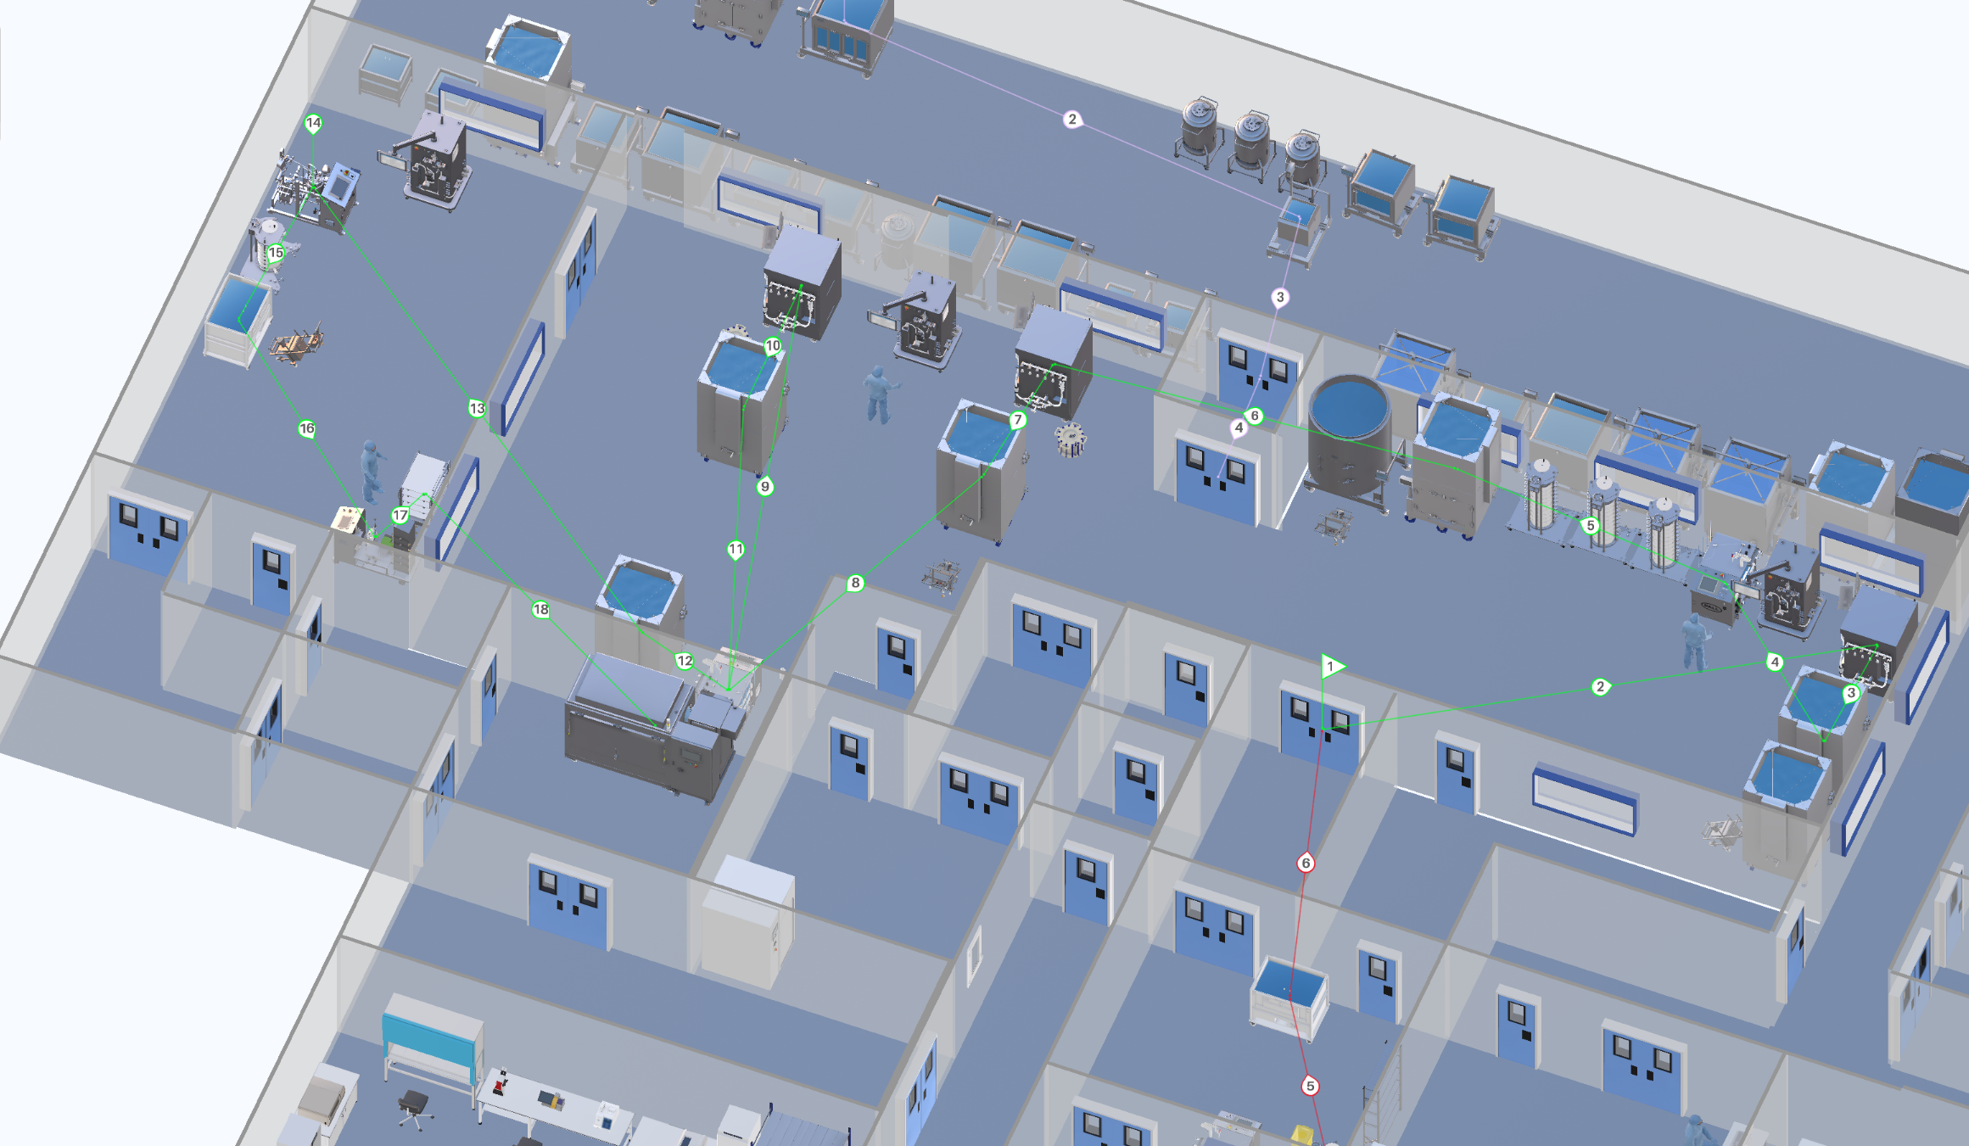

Figure 17: 3D layout of the DSP process (created with HakoBio), The process flow is shown with the green process line and subdivided in 18 process steps.

## Size and function of DSP systems

The required equipment for the DSP rooms, their size and quantity are provided in Table 8, Table 9, Table 10 and Table 11. The DSP relies heavily on single-use peripheral elements, such as connectors, asepti transfer systems, tank liners and valves. Among the single-use equipment worth mentioning is the Allegro™ Connect Buffer Management System. Concentrated buffer solutions from the buffer cold storage room are coupled via an aseptic connection across the wall to the buffer management system in the DSP suites, where they are mixed with WFI and directly available to supply the equipment’s. Furthermore, three ÄKTA™ ready XL systems are located in the DSP V+ room, each dedicated to one chromatography step. This setup allows for more flexibility, especially in cases where upstream or downstream process times could be shortened and several ÄKTA™ ready XL systems could be operated in parallel. Finally, it is worth mentioning the Allegro™ MVP disposable system. This device is an excellent all-rounder for several DSP steps such as virus inactivation, pH adjustment, depth filtration and nanofiltration. Overall, the single-use approach generates higher operating costs and stronger dependence on suppliers. However, the greater flexibility and smaller footprint of the plant (no CIP/SIP required) are a significant advantage, even for DSP. Furthermore, single-use systems are safer due to the decreased risk of microbial contamination, which is of absolute priority in a multiproduct facility.

Table 8: Required equipment for the DSP V+ area.

|  |  |  |  |  |
| --- | --- | --- | --- | --- |
| **DSP V+** | | | | |
| **Equipment** | **Information** | **Quantity** | **Size (WxDxH)**  **[m]** | **Photo** |
| Allegro™ Connect Buffer Management System | In-line buffer dilution system  Energy consumption: 230V | 2 | 1.12x1.12x1.99 | Allegro™ Connect Buffer Management System |
| [2000 L Jacketed Cubical Tank with Load Cell](https://pall.hakobio.com/Portfolio/7fde819d-4c6e-4f9f-aa31-90174e6097fd) | Stainless Steel Tank for Use with Magnetic Mixer Drive Unit | 6 | 1.78x1.39x2.65 | 2000 L Jacketed Cubical Tank with Load Cell |
| 2500 L Jacketed Cubical Tank with Load Cell | Stainless Steel Tank for Use with Magnetic Mixer Drive Unit | 1 | 1.75x1.66x2.29 | 2500 L Jacketed Circular Tank with Load Cell |
| ÄKTA™ ready XL | Single-use chromatography system  Flow rates from 45 to 3500 L/h | 3 | 1.28x1.15x1.95 | ÄKTA™ ready XL single-use system from Cytiva |
| [ReadyToProcess™ 32L columns from Cytiva](https://pall.hakobio2.com/Portfolio/c424a252-e5e4-4856-be4c-4c1617a5e52e) | Chromatography columns for protein A capture | 1 | 0.7x0.7x0.63 |  |
| [ReadyToProcess™ 32L columns from Cytiva](https://pall.hakobio2.com/Portfolio/c424a252-e5e4-4856-be4c-4c1617a5e52e) | Chromatography columns for CIEX | 1 | 0.7x0.7x0.63 |  |
| [ReadyToProcess™ 32L columns from Cytiva](https://pall.hakobio2.com/Portfolio/c424a252-e5e4-4856-be4c-4c1617a5e52e) | Chromatography columns for AIEX | 1 | 0.7x0.7x0.63 |  |
| Allegro™ MVP Single-use system with Quattreflow pump | Multipurpose applications  Energy consumption: 230V | 2 | 0.96x1.28x1.13 |  |
| [Magnetic Mixer Drive Unit](https://pall.hakobio2.com/Portfolio/b48ebc94-36b1-4e9b-b1dd-0f6fa3c8309d) | Robust single-use mixing system | 3 | 0.4x0.82x1.03 |  |
| Stax™ Disposable Depth Filter High Chassis- | Chassis for up to 10 Large Stax Disposable Depth Filters - 21 Depth filters used per batch | 3 | 0.8x1.15x1.93 | Ein Bild, das drinnen enthält.  Automatisch generierte Beschreibung |
| Kleenpak™ Nova Capsule NP6 | For 100L to 1000L  Virus removal filters used with MVP Single-use system | 2 | 0.24x0.24x0.35 | Ein Bild, das Topf enthält.  Automatisch generierte Beschreibung |

Table 9: Required equipment for the DSP V- area.

|  |  |  |  |  |
| --- | --- | --- | --- | --- |
| **DSP V-** | | | | |
| **Equipment** | **Information** | **Quantity** | **Size (WxDxH) [m]** | **Photo** |
| Allegro™ Connect Buffer Management System | In-line buffer dilution system  Energy consumption: 230V | 1 | 1.12 x1.12x1.99 | Allegro™ Connect Buffer Management System |
| Fully Automated Centrasette TFF system | Tangential Flow Filtration System | 1 | 0.8x1.5x1.5 |  |
| [Single-Use TFF Module](https://pall.hakobio2.com/Portfolio/60b5bac3-6af5-42bb-9b08-921ce0f03b38) | Single-Use Module for Concentration/  Diafiltration | 1 | 0.23x0.25x0.09 | Single-Use TFF Module |
| [Stax™ Disposable Depth Filter Medium Chassis](https://pall.hakobio2.com/Portfolio/a382cc57-fefc-4d29-a72a-1f2f5284603c) | Medium chassis for up to 5 Stax Disposable Depth Filters - 4 Depth filters used per batch | 1 | 0.8x1.15x1.31 | Ein Bild, das drinnen enthält.  Automatisch generierte Beschreibung |
| Bulk Filling System |  | 1 | 0.69x1.61x1.58 | Ein Bild, das Gerät enthält.  Automatisch generierte Beschreibung |
| Allegro™ 500L Plastic Tote with Trolley | Collapsible | 1 | 1.22x0.87x1.23 | Allegro™ 500 L Plastic Tote with Trolley |
| Bulk Filling Trolley |  | 1 | 1.02x0.66x1.15 | Bulk Filling Trolley |
| [Magnetic Mixer Drive Unit](https://pall.hakobio2.com/Portfolio/b48ebc94-36b1-4e9b-b1dd-0f6fa3c8309d) | Robust single-use mixing system | 1 | 0.4x0.82x1.03 |  |

Table 10: Required equipment for the DSP Freezing area.

|  |  |  |  |  |
| --- | --- | --- | --- | --- |
| **DSP Freezing** | | | | |
| **Equipment** | **Information** | **Quantity** | **Size (WxDxH) [m]** | **Photo** |
| Ross.pFTU large-scale | Plate-based freeze-thaw unit with control unit | 1 | 3.17x1.39x2.25 | RoSS.pFTU Large-Scale |

Table 11: Required equipment for the DSP Cleaning area.

|  |  |  |  |  |
| --- | --- | --- | --- | --- |
| **DSP Cleaning** | | | | |
| **Equipment** | **Information** | **Quantity** | **Size (WxDxH) [m]** | **Photo** |
| Sterilization Autoclave GSS-L 6710 EC1 | Steam Sterilizer | 1 | 0.66x1.00x0.70 | Sterilization Autoclave GSS-L 6710 EC1 |

# Media and Buffer preparation

Activities involving media preparation are carried out in separate rooms by operators who are outfitted with appropriate protective equipment. Because of the high particle concentration of this combination of dry media and buffer component, rooms are classified as hygienic zone D and are found on the ground floor. In this study case four products A, B, C, and D with the amount of 19, 17, 28 and 9, respectively were considered. The medium preparation consists of 1000 L tank and 2000 L tank and is 37 m2. For the buffer preparation room there are it several tanks, in particular 50 L, 100 L, 500 L, 1’000 L, 1’500 L, 2’000 L, 3’000 L in the area of 192 m2. The buffer cold storage room consists of 124 m2 (Table 26).

## Buffer estimation per batch

During this process, 72 batches per year were carried out for the four different products (A, B, C, D) which makes about 2 batches per week. Due to safety reasons and uncomplicated usage, the inline dilution system was used, except for the buffers D5, D13 and D18.

Inline dilution is a process of transferring buffer concentrate, through an aseptic transport system, and diluting it with water directly at the site of use. As a result of using this technique, the efficiency and flexibility are exceeded. It enables to lower facility’s footprint, as well as reduced utilities and equipment costs in the long run. One of the biggest disadvantages is the insurance of the quality of mixed buffer, due to physical difficulties with controlling it. (ispe.org, 2019)

Table 12: Calculations of the required volumes of the different buffers per batch.

|  |  |  |  |  |  |
| --- | --- | --- | --- | --- | --- |
| **Number** | **Buffer** | **Volume per batch [L]** | **Volume per two batch (one week) [L]** | **Volume concentrate per week [L]** | **Storage** |
| D1 | Wash 1 Buffer Chroma I | 6776 | 13552 | 2711 | 3000 |
| D2 | Wash 2 Buffer Chroma I | 3080 | 6160 | 1232 | 1500 |
| D3 | Wash 3 Buffer Chroma I | 3080 | 6160 | 1232 | 1500 |
| D4 | Elution Buffer Chroma I | 4312 | 8624 | 1725 | 2000 |
| D5 | NaOH 1M | 960 | 1920 | - | 2000 |
| D6 | Regeneration Buffer Chroma III | 2304 | 4608 | 922 | 1000 |
| D7 | Equilibration Buffer Chroma III | 3006 | 6012 | 1202 | 1500 |
| D8 | Pre-/ Sanitization Buffer Chroma III | 1816 | 3632 | 726 | 1000 |
| D9 | Wash Buffer 2 Chroma II | 1135 | 2270 | 454 | 500 |
| D10 | Elution Buffer Chroma II | 1589 | 3178 | 636 | 1000 |
| D11 | Strip Buffer Chroma II | 681 | 1362 | 272 | 400 |
| D12 | Equilibration Buffer Chroma III | 833 | 1666 | 333 | 400 |
| D13 | Equilibration / Flush Buffer Nano Filtration | 251 | 502 | - | 400 |
| D14 | Diafiltration Buffer UF/DF2 | 4099 | 8198 | 1640 | 2000 |
| D15 | Acid Buffer Viral Inactivation | 154 | 308 | 62 | 100 |
| D16 | Base Buffer Viral Inactivation | 161 | 322 | 64 | 100 |
| D17 | Chroma I Storage Buffer 20% EtOH | 924 | 1848 | 370 | 400 |
| D18 | pH Adjustment Buffer | 226 | 452 | - | 500 |
| D50 | NaOH 0.01 M Storage Buffer | 852 | 1704 | 341 | 400 |
| D51 | NaOH 0.5 M | 431 | 862 | 172 | 200 |
| D53 | NaOH 0.1 M | 340 | 680 | 136 | 200 |

## Plant on a page

Media and feed preparation has an important role in this process and especially for the upstream process that follows. The following volumes of media and feed (see Table 13) are required for the different bioreactors during the process:

Table 13: Volume data for medium and feed for the entire process

|  |  |  |
| --- | --- | --- |
| **Bioreactor** | **Media** Volume/batch [L] | **Feed** Volume/batch [L] |
| Seed Bioreactor 1 | 16 | 4 |
| Seed Bioreactor 2 | 160 | 40 |
| Production Bioreactor | 3x 1’600 | 3x 400 |

The medium and feed are prepared in stirred tanks and then distributed into transportable bags, where each bioreactor in the upstream process receives the corresponding volume size. The plant on a page is showed on Figure 18.

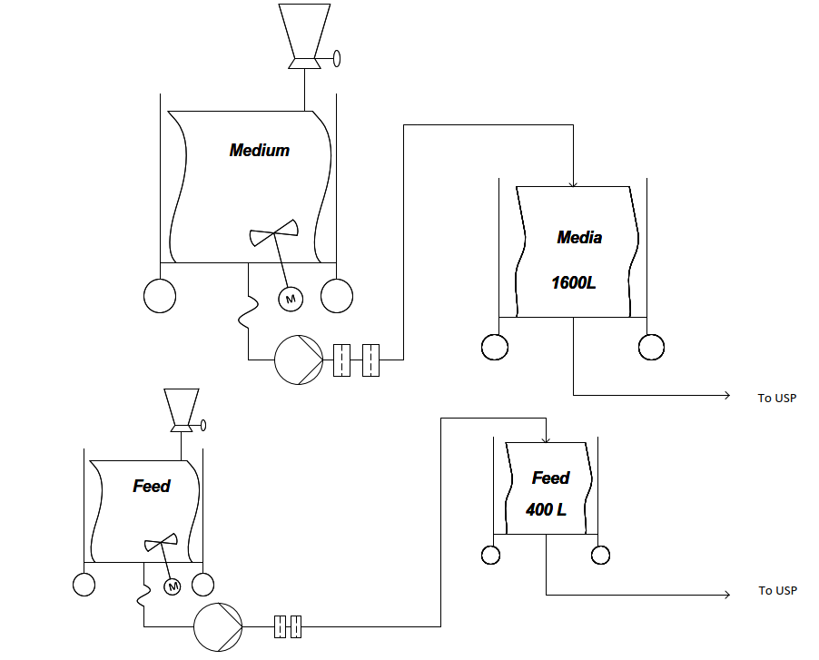

Figure 18: Plant on a page of media and feed preparation for the USP. Image created with Visio®.

Based on the calculations for the buffer preparation, a plant on a page (seen in Figure 19) was designed. Each buffer concentrate is produced in a large production reactor and then stored in a tank. The transport of the buffers to the DSP takes place through the inline dilution system. Buffer D5, D13 and D18 are transported through transportable bags and all other buffers through hard pipes.

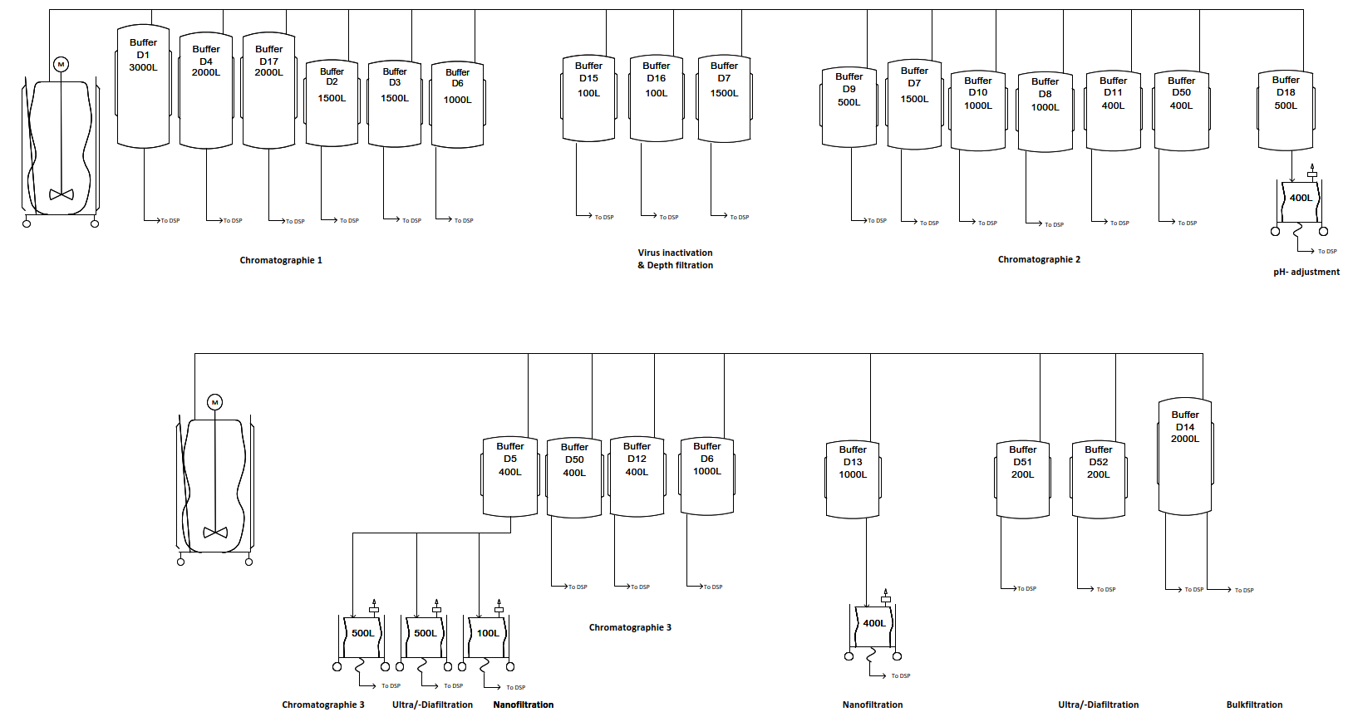

Figure 19: Plant on a page of buffer preparation for the DSP. Image was created with Visio®.

## HakoBio room concept of media and buffer preparation

### Room concept of Media & feed preparation & storage room

The room has 37 m2 and is placed close to the USP production, to enable easier and shorter transport of already prepared media and feed to the upstream production. All the used tanks are going to be mobile, and ready for transit of needed materials. The room is depicted in the Figure 20.

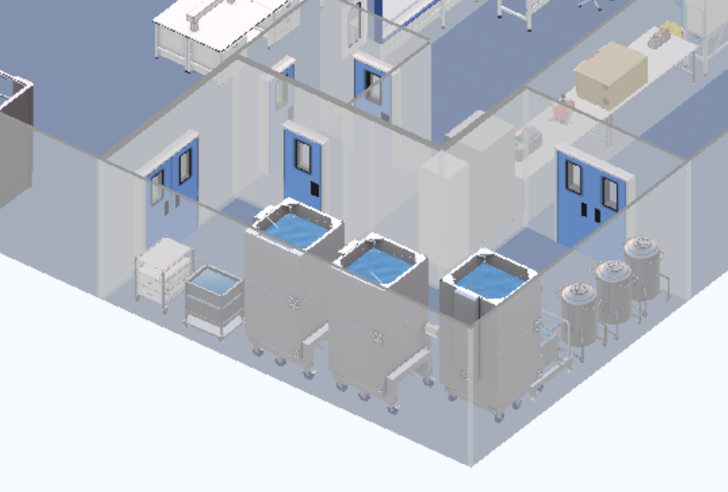

Figure 20: Media & feed preparation & storage room. Image created with HakoBio.

### Room concept of buffer preparation & storage

The buffer preparation has 192 m2 and storage room has 124 m2 and is right next to the DPS production.

The inline dilution system will be used for 18 out of 21 buffers, which made it necessary to place those two rooms close to each other so that the process of transferring buffer into downstream production does not disturb other production steps or the work organization of the whole facility. For the remaining three buffers system with preparation in separate tanks and delivery with the use of mobile tanks was chosen, due to difficulties with the placement of the equipment in the DSP production.

Despite the current trend of working with single-use technologies, it was decided to use regular tanks for preparation and storage, due to the very small variation of the used buffers in between the products. The buffer prep and storage room are depicted in the Figure 21.

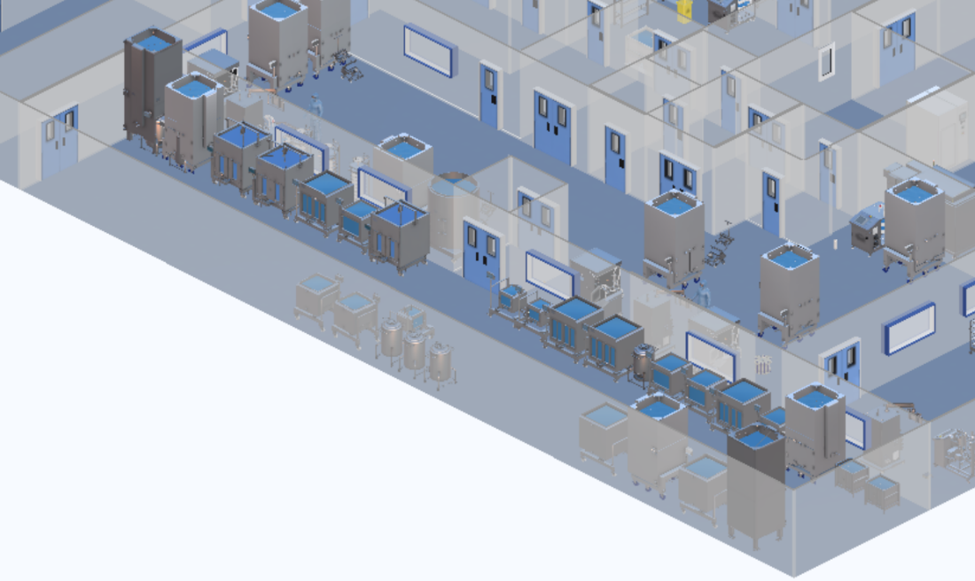

Figure 21: Buffer preparation & storage room. Image created with HakoBio.

## Size and function of MP and BP systems

The equipment needed for media and buffer preparation and storage in mAb manufacturing is listed in this paragraph. Table 14 and Table 15 show the different sorts of materials, as well as their number and size. For the design of a biopharmaceutical facility, a review of the equipment required, and its scale is critical.

Table 14: Size and Function of Media Systems

|  |  |  |  |
| --- | --- | --- | --- |
| **Media and feed storage and preparation room** | | | |
| **Equipment** | **Quantity** | **Size in m** | **Photo** |
| 2000 L Jacketed Cubical Tank with Load Cell | 3 | 1.78 x 1.39 x 2.65 |  |
| 200 L stainless steel Bioreactor with Trolley | 1 | 0.82 x 0.65 x 1.2 |  |
| 2 x 20 L Biocontainers with Trolley | 1 | 0.71x1.05x0.98 |  |
| 500 L formulation tank | 3 | 0.72 x 0.83 x 1.39 |  |
| 100 L Jacketed Cubical Tank with Load Cell, Stainless Steel | 1 | 1 x 0.86 x 1.58 |  |

Table 15: Size and Function of Buffer Systems

|  |  |  |  |
| --- | --- | --- | --- |
| **Buffer storage and preparation room** | | | |
| **Equipment** | **Quantity** | **Size in m** | **Photo** |
| 3000 L Jacketed Cubital Tank with Load Cell | 1 | 1.64 x 1.40 x 3.56 |  |
| 2000 L Jacketed Cubical Tank with Load Cell | 2 | 1.78 x 1.39 x 2.65 |  |
| 1500 L Jacketed Cubical Tank with Load Cell | 3 | 1.62 x 1.39 x 2.17 |  |
| 1000 L Jacketed Cubical Tank with Load Cell | 3 | 1.53 x 1.29 x 1.60 |  |
| 500 L Formulation tank | 4 | 0.72 x 0.83 x 1.39 |  |
| 400 L Jacketed Cubical Tank with Load Cell | 5 | 1.27 x 1.01 x 1.58 |  |
| 200 L stainless steel Bioreactor with Trolley | 3 | 0.82 x 0.65 x 1.2 |  |
| 100 L stainless steel Tank | 3 | 1.00 x 0.86 x 1.58 |  |

# Quality Control

A rock-solid quality control (QC) is needed to produce four different mAb products. The QC will perform quality analysis of many different parameters, which are essential to the end quality of a product. Analysis will be performed on the raw materials, intermediate products which will be obtained during each step during the process and the end product itself. To fulfil these tasks a laboratory was designed with equipment’s such as a Cell counter, Spectrophotometer and other analytical devices listed in the chapter below. Since Hakobio does not support analytical apparatus such as Liquid Chromatography, they have not been included. A total of 16 FTEs will be working in the Quality department, 5 for the QA and 11 for the QC.

## HakoBio room concept of the QC Laboratory

The laboratory has a footprint of 70 square meters, with an occupancy of 22%. It has been designed to allow the QC staff to work comfortably on their task, with room to move around and space on the tables next to the instruments for samples and flasks. The Figure 22 shows the 3D model of the room and its contents. A fridge, a freezer and shelving have been attributed to have all the necessary reagents and solvents at hand, as well as a autoclave to destroy biowaste inside the lab directly. All the contents of the QC laboratory are described in Table 16.

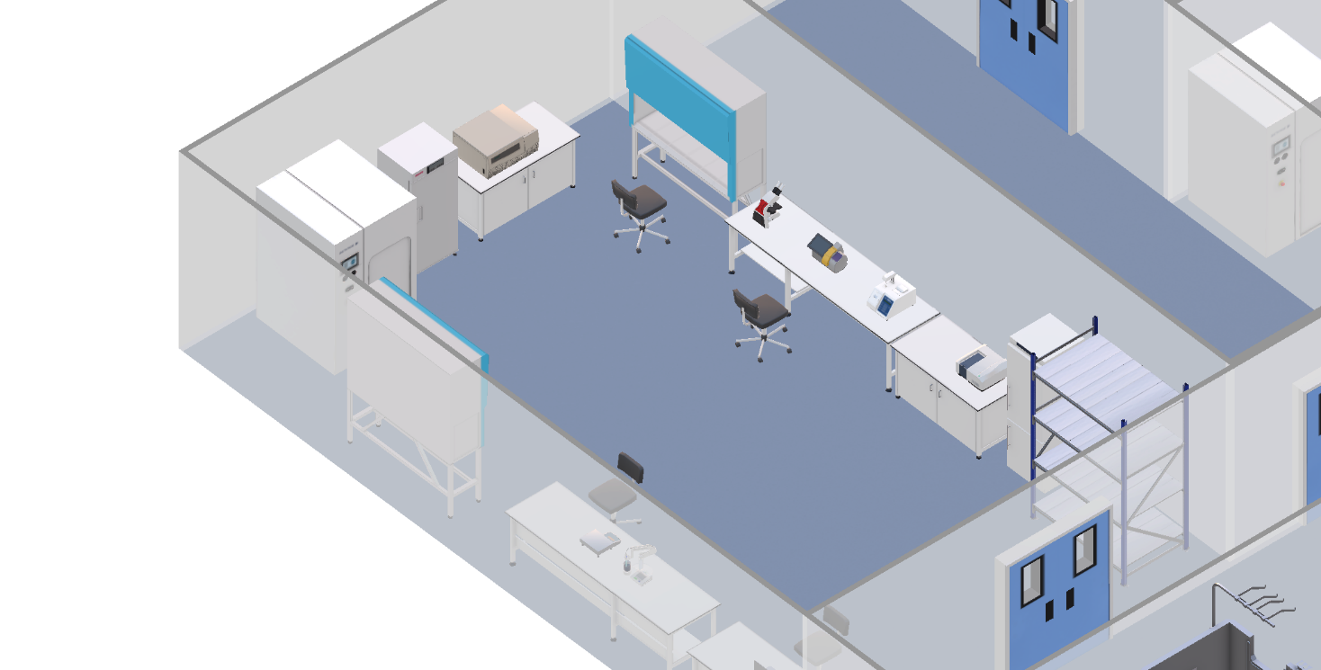

Figure 22: HakoBio 3D Drawing of the QC Lab

## Size and functions of QC systems

Table 16: Size and Function of the QC Lab

|  |  |  |  |
| --- | --- | --- | --- |
| **Quality Control Sytems** | | | |
| **Equipment** | **Quantity** | **Size in m** | **Photo** |
| Laminar Flow Hood | 2 | 1.78 x 0.59 x 2.2 |  |
| Nucleocounter NC-200 Automated Cell Counters | 1 | 0.46 x 0.26 x 0.26 |  |
| Leica DM750 Optical Microscope | 1 | 0.2 x 0.37 x 0.44 |  |
| 3250 Single Sample Osmometer | 1 | 0.33 x 0.46 x 0.41 |  |
| V-730 UV-Vis Spectrophotometer | 1 | 0.47 x 0.44 x 0.23 |  |
| Midrics Complete Bench Scale | 1 | 0.32 x 0.39 x 0.1 |  |
| SevenCompact pH meter S220 | 1 | 0.35 x 0.36 x 0.38 |  |
| Laptop | 1 | 0.34 x 0.24 x 0.24 |  |
| Allegra X-15R Centrifuge | 1 | 0.77 x 0.63 x 0.36 |  |
| Freezer MDF-U333 | 1 | 0.75 x 0.62 x 1.64 |  |
| Lab Combined refrigerator-freezer | 1 | 0.6 x 0.7 x 2.01 |  |
| Sterilization Autoclave GSS-L 6710 EC1 | 1 | 0.66 x 1 x 0.7 |  |
| Chair | 4 | 0.66 x 0.66 x 0.86 |  |
| Large Benchtop | 2 | 2.83 x 0.8 x 0.8 |  |
| Small Benchtop | 2 | 1.52 x 0.81 x 0.8 |  |

# Clean facility utilities

## List of necessary clean and technical utilities

The biopharmaceutical manufacturing uses a multitude various, precise processes that require different resources and energies, for example water, electricity, and compressed air. These can be classified into “Clean Utilities and Technical Utilities (also called Black Utilities)” categories (see Table 17) (Joseph, 2018).

Table 17: List of clean and technical utilities.

|  |  |
| --- | --- |
| **Clean Utilities** | **Technical Utilities (Black Utilities)** |
| Water for Injection (WFI) | Wastewater Collection/ Inactivation (Bio / non-Bio) |
| Purified Water (PW) | Water (Portable, Cooling, Heating and Fire Water) |
| Clean Steam | Compressed Air |
| Clean Compressed air | HVAC |
| Process Air | Electrical Power |
| Process Gases (N2, O2, CO2) | Technical Steam (Black Steam – Fresh / Used) |
|  | Waste (Plastics / Paper / Other) |
|  | Gasoline |
|  | Nitrogen Liquid |

## HVAC

The HVAC system should provide for the worker a well-appointed working environment as well as the provider of rooms and the manufacturing process with the required grade of cleanliness and pressurization to ease cGMP and BSL requirements for manufacturing. The basic four HVAC system functions are depicted in Table 18 (Joseph, 2018).

Table 18: HVAC system and their respective functions.

|  |  |
| --- | --- |
| **HVAC system** | **Functions** |
| **Maintain room cleanliness** | * Control of airborne particles, dust, and micro-organisms   + Performed through air filtration using high-efficiency particulate air (HEPA) filters |
| **Maintain room pressure** | * Air flow must come from the cleaner area toward the adjoining space   + To reduce the chance of airborne contamination   + Achieved by more air into the cleaner space than is mechanically removed from that same space |
| **Maintain space moisture** | * Controlled by cooling air to dew point temperatures or by using desiccant humidifiers   + Can affect the efficacy and stability of drugs |
| **Maintain space temperature** | * Can affect production   + Directly by impacting chemical or biochemical reactions   + Indirectly by fostering growth of microbial contaminants in the process or on workers |

## Clean utilities

Clean utilities have a direct impact on the quality of the product; therefore, they are defined as the necessary requirements by the production process. The cleanliness of the utilities must be as pure as possible to make sure that no novel contaminant is introduced into the production process. Clean utilities comprise (Joseph, 2018):

Table 19: Functions of clean utilities

|  |  |
| --- | --- |
| **Clean Utilities** | **Utilized for** |
| **WFI and PW** | * To produce buffers and cell culture media * For CIP operations |
| **Clean Steam** | * For sterilization of product contacting surface |
| **Clean Compressed Air** | * For blow down of transfer pipes and drying of product contacting surface after cleaning and sterilizing * Pneumatic valves within the transfer pipe network and unit operations |
| **Clean Process Gases** | * Within the cell culture processes |

### List of equipment used for clean utilities

A list of the main equipment used for clean utilities is provided in the Table 20. The table is intended to show a simplified summary of all the necessary equipment lists for clean utilities. The major components in a clean utility are shown, followed by where they can be found (stages). Then all equipment necessary for production / generation is listed below (Joseph, 2018).

Table 20: List of equipment for clean utilities.

|  |  |  |  |  |  |  |
| --- | --- | --- | --- | --- | --- | --- |
| **PW** | **WFI** | **Clean Steam** | **Clean Compressed air** | **Process Air** | **Process Gases** | **Liquid Nitrogen** |
| ***Basement*** | ***Basement*** | ***Basement*** | ***Basement*** | ***2nd Floor*** | ***Outside*** | ***Outside*** |
| Heat exchanger | Heat exchanger | Distillation Column | Filters | Filters | Storage Tanks for all gases | Storage Tank |
| Storage Tank | Storage Tank | Compressor | Pneumatic Valve | Cooler | Pneumatic Valve | Pneumatic Valve |
| Reverse Osmosis | Distillation Column | - | Storage | Heater + Reheaters | - | - |
| Nano Filtration | - | - | Compressor | Humidifier | - | - |
| Water Treatment | - | - | - | Mixing Chambers | - | - |

### Water requirements

In Table 21 the total amount of water (in liters, L) required for USP and DSP is shown. These numbers have been estimated from the numbers given by the DSP, USP block flow diagrams and the URS.

Table 21: Liters of water required for USP and DSP.

|  |  |  |  |  |  |
| --- | --- | --- | --- | --- | --- |
|  | **WFI\*** | **PW\*** | **Solid Waste\*** | **Liquid Waste\*** | **Liquid Biological\*\*** |
| **DSP** | 3541 | - | 625 | 42000 | - |
| **USP** | - | 2500 | - | - | 2500 |

## WFI, PW and clean steam

The biopharmaceutical manufacturing uses water, which needs to be suitable for the process steps. This generally means it must be as clean as necessary regarding bioburden, particles and soluble. The kind of clean water which is necessary for each step is determined by the process step. The purity is measured by conductivity, pH, total organic carbon, and endotoxin content. The designer must consider the different grades of water production depending to the United States Pharmacopeia (USP), WHO, or European Pharmacopoeia (EUPH) or other region-specific guidelines which are portable water, purified water (PW) and water for injection (WFI). Each kind of water is “cleaner” as the type before (Joseph, 2018).

Portable water is basically tab water while PW and WFI are generated in a cascade in a continuous manner (see Figure 23). The process is guided under GMP and starts with drinkable water of the local provider, also defined, or described as potable water. The potable water is filtered by Nanofiltration and followed by UV sterilization. Then it will be transferred to the reverse osmosis system. Reverse osmosis is used to produce WFI. In order to have a continuous flow even if filters must be exchanged 2 reverse osmosis system are installed as well as 2 nanofiltration systems. The PW can be used for USP, DSP, MP and BP. Clean steam is also generated from PW via distillation and is predominantly used for cleaning. For the WFI generation, the PW goes through a multi-distillation column which saves energy. WFI is also used in USP, DSP, MP and BP (Joseph, 2018).

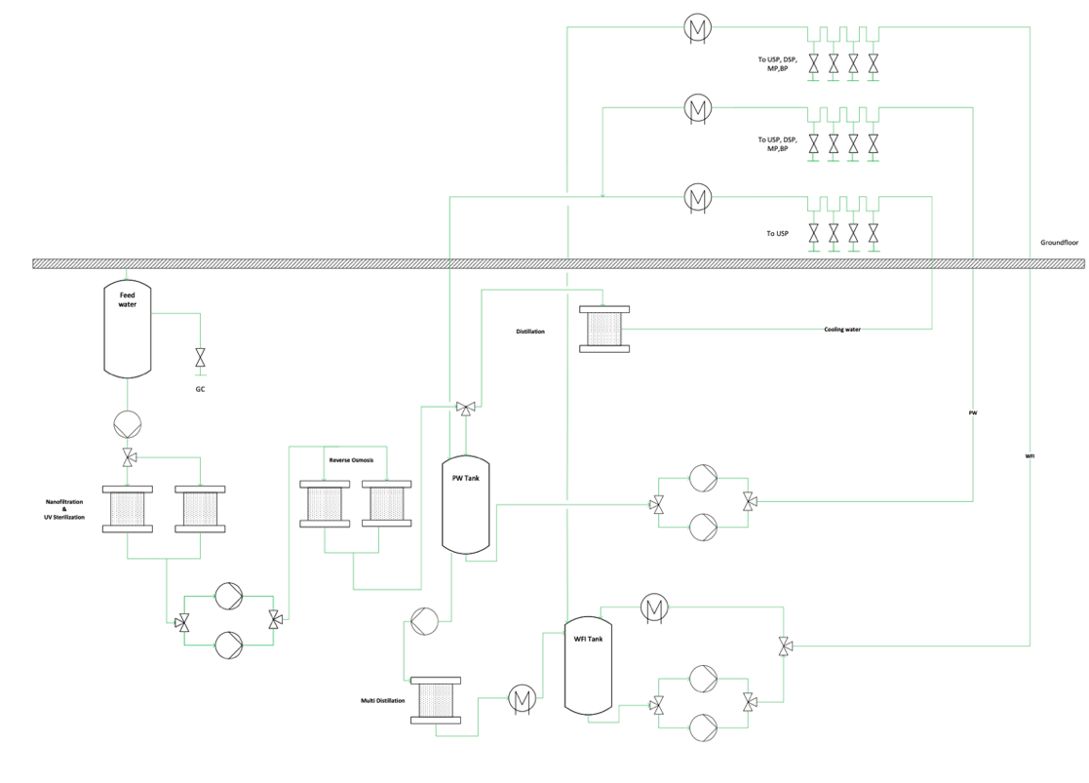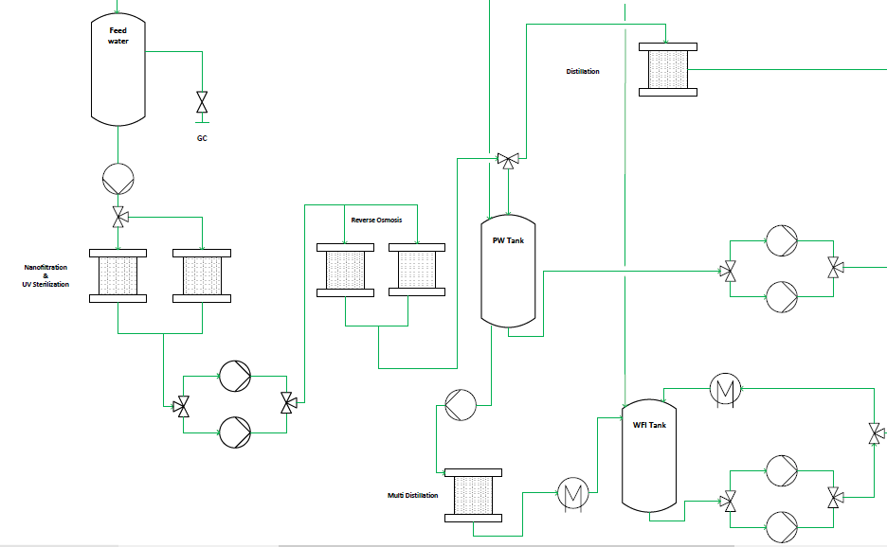

Figure 23: Plant on a page of PW, WFI and clean steam systems. Designed with Visio®. The right figure zooms in the production part of the WFI-plant.

### Characteristics of the system

Dead legs need to be minimized to avoid stagnant water (bioburden), material = Stainless Steel 316L, constant turbulent flow needs to be achieved through the pumps to reduce bacterial growth, a positive pressure between the loop and Points of use (POUs) needs to be guaranteed to avoid contamination, adequate slope of piping toward the drains needs to be achieved to allow complete drainage, air breaks to wastewater need to be installed to eliminate backwash, two pumps are used for redundancy.

There are two types of steams which are required within the biopharmaceutical facility (Joseph, 2018). The difference is seen in Table 22.

Table 22: Types of steam and their function.

|  |  |  |
| --- | --- | --- |
| **Kind of steam** | **Production** | **Used for** |
| **Technical/**  **Black steam** | Produced from a boiler | Heating of non-product contacting surfaces and systems |
| **Clean steam** | Generated from treated water free of volatile additives | Thermal disinfection or sterilization processes  For sterilization of products, and more typically equipment |

A steam produced by a boiler is pressurized and used to produce the clean steam of the clean steam distillation column.

## Technical utilities

Technical utilities, also known as black utilities, are used for the direct support of the process operation, while it does not have a direct contact with the product. Technical utilities may comprise the elements listed in Table 23 (Joseph, 2018).

Table 23: Technical utilities functions

|  |  |
| --- | --- |
| **Technical Utilities** | **Utilized for** |
| Potable water | * To higher grades of water * To use within the domestic systems of a facility |
| Fire Water | * For the safety |
| Cooling/chilled water/glycol | * For non-product contact cooling applications |
| Hot water/technical steam | * Required for non-product contact heating applications |
| Electrical power | - |
| Natural or liquefied gas | * Needed for firing gas boilers |
| Wastewater collection/inactivation | - |

## Waste

During biopharmaceutical processes waste is always generated. The majority of the waste is from the production process steps and can be classified in biological waste and non-biological waste. For instance, the kind of waste in an upstream process can be generated during the cell growth media, bioreactor, media culture hold bags, filters, and tubing or during the steam in place process a steam waste can be generated. Waste can be differentiated to solids, liquids, and gases. The kind of waste is summarized in the following Table 24 with their impact (Joseph, 2018).

Table 24: Types of waste and their impact.

|  |  |
| --- | --- |
| **Waste type** | **Impact of waste** |
| **Non-Bioactive Waste** | * Directly discarded or slightly treated to diminish the environmental impact |
| **Liquids** | * Non-biological liquids waste * Collection within a waste tank followed by chemical treatments * Harmful waste   + Further purification processing ma required |
| **Solids** | * Biologically exposed solid waste   + Sanitized either via an autoclave or chemically * Non-active solid waste   + Can be double-bagged and taken out of the facility to landfill or incineration sites, depending on local practices * Like non-biological liquid waste: some deactivation may require by some means prior to exiting the facility. |
| **Exhausted Air** | * Non-hazardous exhausted air   + From vent filters not hazardous to health or environment * Odorous or solvent vapors   + Deodorization or organic solvent emission reduction |
| **Hazardous Waste Decontamination** | * Can be solid and liquid waste * Decontamination systems   + Must ensure inactivation of all microorganisms, including survival structures   + Processes must be validated by microbial challenge testing |

## Zone Concept Basement

The zone concept of the basement is shown below in Figure 24. In here, the rooms corresponding to clean and technical utilities can be found. Both the room design and selection of equipment were performed in HakoBio’s platform. Due to lack of availability of the actual equipment described in the previous section, the equipment portrayed was selected as an alternative. The electricity room was left empty for the previously mentioned reason.

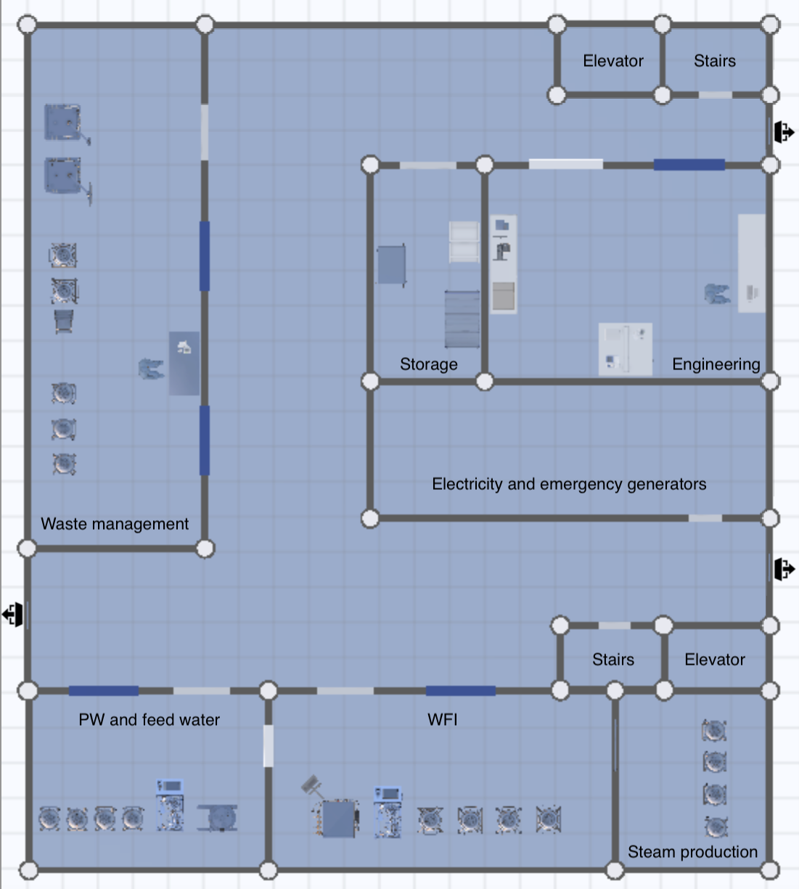

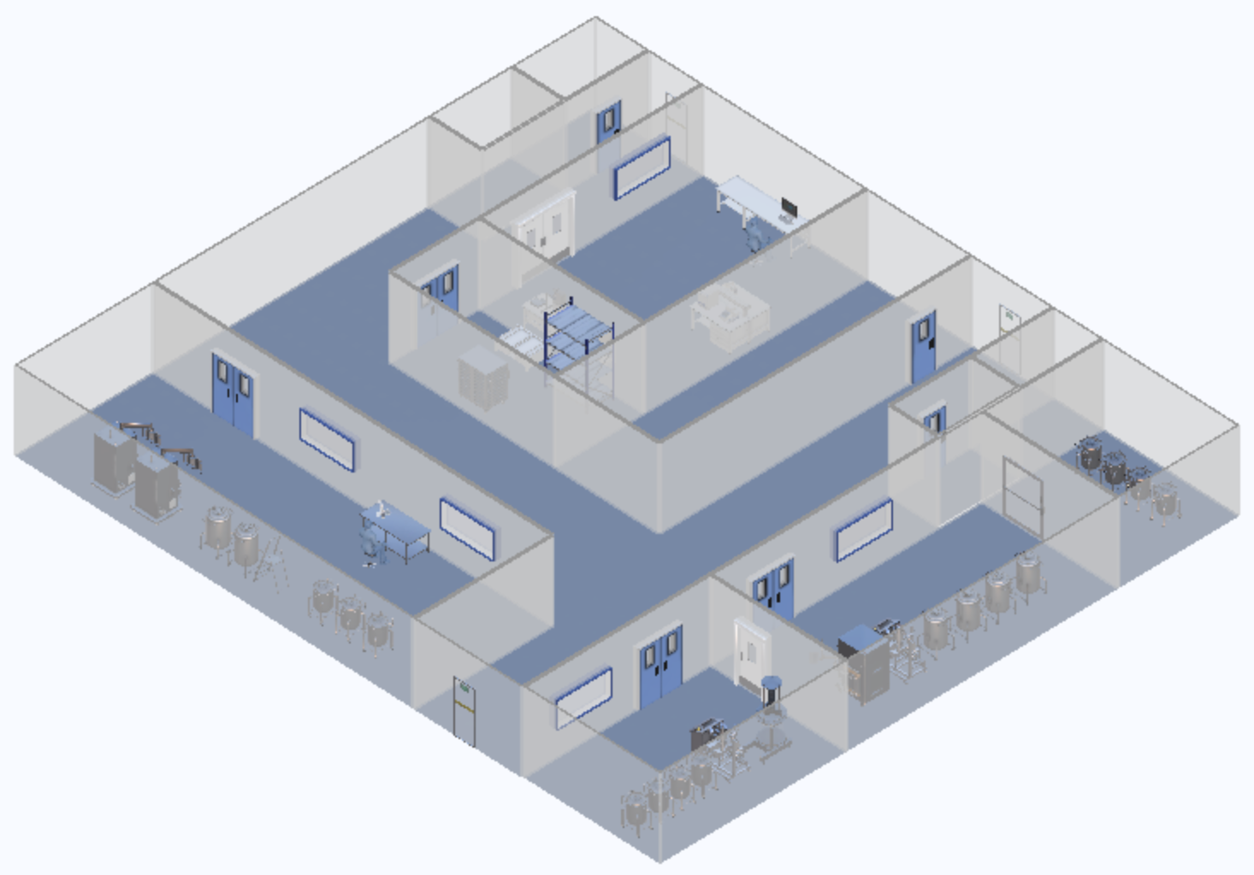

Figure 24: Room concept of the basement designed with HakoBio. The basement is depicted in 2D (upper image) and 3D (lower image).

### Points of use

The points of use are depicted in Figure 25 and indicated per process in Table 25*.* The first step to design the points of use zone concept, was to determine which utilities were required for the different processes and their respective rooms. For the clean utilities, rooms such as media preparation, buffer preparation & storage, Inoculum, USP production, USP harvest and DSP V+ have points of use for both Water for Injection (WFI) and Potable Water (PW). For the quality room, only PW has been supplied. Points of use for Clean compressed air are present in the USP production and USP harvest for cell cultivation and fermentation processes. This clean utility is also present in buffer preparation & storage, and DSP V+, with the last one requiring two points of use. For the process air, a point of use in the USP production room was included. In addition to this, a supply for process gases (N2, O2, CO2) are present in the USP production, USP harvest and inoculum rooms. A single point of use for clean steam is set in buffer preparation & storage. The technical facilities such as biological, liquid, and solid waste are distributed across the main rooms of buffer and media preparation, USP and DSP. Since biological active waste must be inactivated prior to disposal, a waste management room was design to carry out the inactivation.

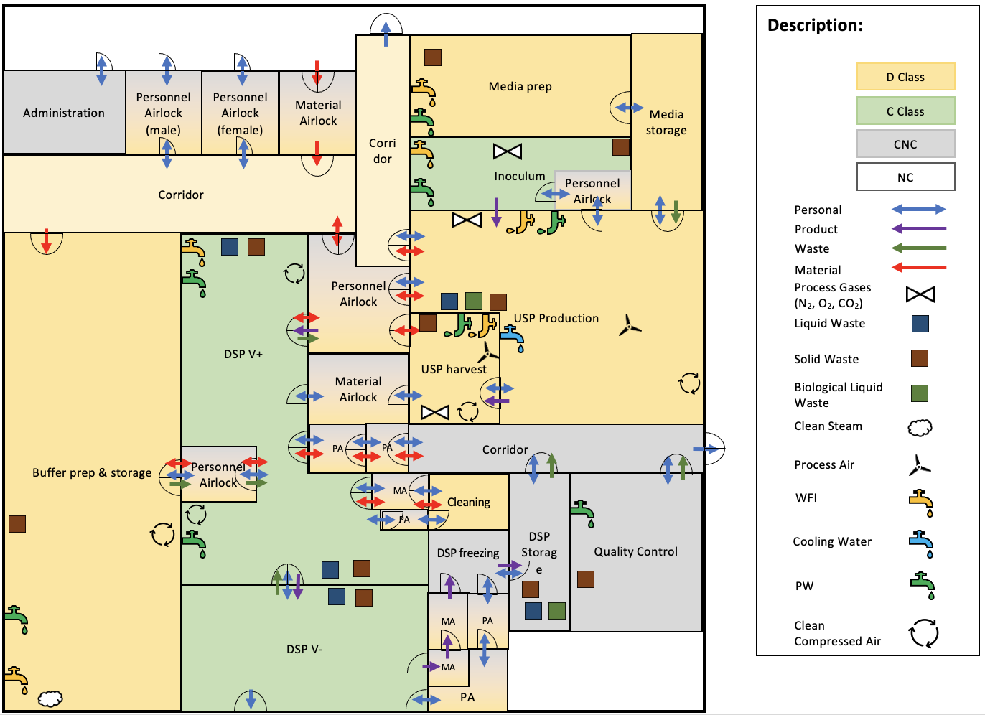

Figure 25: HVAC and points of use in the zone concept of the production area of the ground floor.

Table 25: Points of use of clean and technical utilities per process



# References

Appendix B – Large Scale Biosafety Guidelines. (2010). In *Guidelines for Process Safety in Bioprocess Manufacturing Facilities* (S. 161–176). John Wiley & Sons, Ltd. https://doi.org/10.1002/9780470949146.app2

Council Directive 90/679/EEC, CONSIL, 374 OJ L (1990). http://data.europa.eu/eli/dir/1990/679/oj/eng

David J. Pollard, Alain Pralong. (2018). *Single-Use Technology Implementation For Biologics and Vaccines Production*.

Eibl, R., & Eibl, D. (Hrsg.). (2019). *Single-use technology in biopharmaceutical manufacture* (Second edition). Wiley.

Gareth John Macdonald. (2020). *Single-Use Tech Key for Capacity Hike Required for COVID-19*. https://www.genengnews.com/topics/bioprocessing/single-use-tech-key-for-capacity-hike-required-for-covid-19/

Gareth Macdonald. (2020). *Single-use tech unstoppable if suppliers meet demand—Bioprocess InsiderBioProcess International*. https://bioprocessintl.com/bioprocess-insider/upstream-downstream-processing/single-use-tech-unstoppable-if-suppliers-can-meet-soaring-demand-says-gsk/

ispe.org. (2019). *Inline Dilution: An Agile Capability for Downstream Manufacturing*. ISPE | International Society for Pharmaceutical Engineering. https://ispe.org/pharmaceutical-engineering/may-june-2019/inline-dilution-agile-capability-downstream-manufacturing

Joseph, J. (2018). Facility Design and Process Utilities. In *Biopharmaceutical Processing* (S. 933–986). Elsevier. https://doi.org/10.1016/B978-0-08-100623-8.00045-1

Lopes, A. G. (2015). Single-use in the biopharmaceutical industry: A review of current technology impact, challenges and limitations. *Food and Bioproducts Processing*. https://10.1016/j.fbp.2013.12.002

Miller, S. R., & Bergmann, D. (1993). Biocontainment design considerations for biopharmaceutical facilities. *Journal of Industrial Microbiology*, *11*(4), 223–234. https://doi.org/10.1007/BF01569595

Parrish M. Galliher. (2018). *Single Use Technology and Equipment*.

Schirmer, C., Maschke, R. W., Pörtner, R., & Eibl, D. (2021). An overview of drive systems and sealing types in stirred bioreactors used in biotechnological processes. *Applied Microbiology and Biotechnology*, *105*(6), 2225–2242. https://doi.org/10.1007/s00253-021-11180-7

List of figures

Figure 1: Organigram of group 3. The member of each subgroup are inside of each subgroup fields and their affiliated schools, from the MSLS-alliance, are written next to the respective names. The group supervisor is Fruhar Mozaffari. 3

Figure 2: Occupany list of USP, DSP with media and buffer flow. 7

Figure 3: Occupancy list specific for DSP. Every step, which will be conducted is listed, with the estimated time in hours to perform the downstream steps. 7

Figure 4: Block flow diagram of product A. 10

Figure 5: Block flow diagram of product B. 11

Figure 6: Block flow diagram of product C. 12

Figure 7: Block flow diagram of product D. 13

Figure 8: Zone concept of the biopharmaceutical production facility regarding the ground floor. 17

Figure 9: Zone concept of the 1st floor. Mostly offices and conference rooms are located on this floor. 18

Figure 10: Zone concept of the 2nd floor. This level contains the HVAC system. 19

Figure 11: Height concept of the designed production facility for mAb production. The different floors, with their respective heights can be seen, as well as the heights of the attached buildings e.g., warehouse. 20

Figure 12: 3D layout of the production area made using the program HakoBio. The different room names are written in the respective blocks, pointing with an orange arrow to the location. 22

Figure 13: 2D layout of the production area made with the program HakoBio. The orange arrows indicate the product flow and the number in the blocks indicates the steps taken during the production. 23

Figure 14: USP Plant on a page 27

Figure 15: 3D layout of the USP process (created with HakoBio), The process flow is shown with the red process line, starting in the inoculum room (1), seeding (2) and production (3) room, followed by the transfer (4) to the harvest room (5), where the depth filtration is performed. Lastly transferring the production further to the DSP (6). 28

Figure 16: DSP Plant on a page. 35

Figure 17: 3D layout of the DSP process (created with HakoBio), The process flow is shown with the green process line and subdivided in 18 process steps. 36

[Figure 18: Plant on a page of media and feed preparation for the USP. Image created with Visio®. 44](https://zhaw.sharepoint.com/sites/BP3Group32/Freigegebene%20Dokumente/General/BP3_group_3_final.docx#_Toc96072183)

[Figure 19: Plant on a page of buffer preparation for the DSP. Image was created with Visio®. 45](https://zhaw.sharepoint.com/sites/BP3Group32/Freigegebene%20Dokumente/General/BP3_group_3_final.docx#_Toc96072184)

Figure 20: Media & feed preparation & storage room. Image created with HakoBio. 46

Figure 21: Buffer preparation & storage room. Image created with HakoBio. 47

Figure 22: HakoBio 3D Drawing of the QC Lab 51

[Figure 23: Plant on a page of PW, WFI and clean steam systems. Designed with Visio®. The right figure zooms in the production part of the WFI-plant. 59](https://zhaw.sharepoint.com/sites/BP3Group32/Freigegebene%20Dokumente/General/BP3_group_3_final.docx#_Toc96072188)

Figure 24: Room concept of the basement designed with HakoBio. The basement is depicted in 2D (upper image) and 3D (lower image). 62

Figure 25: HVAC and points of use in the zone concept of the production area of the ground floor. 63

List of tables

Table 1: Advantages and disadvantages of single-use technology (SUT) in production processes of biologics and other pharmaceutical products. (Eibl & Eibl, 2019) 2

Table 2: Requirements from the URS and calculations for the required batches regarding the four mAb products (A to D). 4

Table 3: Required production lines and estimated operational time of the production facility within a year. 5

Table 4: Area schedule and room list 14

Table 5: Heights of the different rooms based on the height concept, in meters. 21

Table 6: FTE estimation in different areas of occupations, in the designed facility. 24

Table 7: Equipment for USP in mAb production 29

Table 8: Required equipment for the DSP V+ area. 37

Table 9: Required equipment for the DSP V- area. 39

Table 10: Required equipment for the DSP Freezing area. 41

Table 11: Required equipment for the DSP Cleaning area. 41

Table 12: Calculations of the required volumes of the different buffers per batch. 43

Table 13: Volume data for medium and feed for the entire process 44

Table 14: Size and Function of Media Systems 48

Table 15: Size and Function of Buffer Systems 49

Table 16: Size and Function of the QC Lab 52

Table 17: List of clean and technical utilities. 55

Table 18: HVAC system and their respective functions. 56

Table 19: Functions of clean utilities 56

Table 20: List of equipment for clean utilities. 57

Table 21: Liters of water required for USP and DSP. 57

Table 22: Types of steam and their function. 60

Table 23: Technical utilities functions 60

Table 24: Types of waste and their impact. 61

Table 25: Points of use of clean and technical utilities per process 64

Table 26 Calculations of the required volumes of the different buffers per batch. I

List of equations

Equation 1: Formula to calculate the required staff, dependent on the workdays, number of shifts and employees in an area. 24

Equation 2: Total amount of batches per year needed, of all the four mAb products (A to D), to fulfill the URS of the production facility. 25

Equation 3: Calculation for number of batches needed to produce the defined amount of mAb product A according to the USR, for a year. 26

Equation 4: Calculation for the number of required production bioreactors. 26

Equation 5: Calculation for the number of required seed lines. 26

Equation 6: Calculation for the number of required inoculum lines. 26

# Appendix

Table 26 Calculations of the required volumes of the different buffers per batch.

|  |  |  |  |  |  |
| --- | --- | --- | --- | --- | --- |
| **Number** | **Buffer** | **Product A**  Volume/batch [L] | **Product B**  Volume/batch [L] | **Product C**  Volume/batch [L] | **Product D**  Volume/batch [L] |
| D1 | Wash 1 Buffer Chroma I | 6776 | 6776 | 6776 | 6776 |
| D2 | Wash 2 Buffer Chroma I | 3080 | 3080 | 3080 | 3080 |
| D3 | Wash 3 Buffer Chroma I | 3080 | 3080 | 3080 | 3080 |
| D4 | Elution Buffer Chroma I | 4312 | 4312 | 4312 | 4312 |
| D5 | NaOH 1M | 960 | 960 | 960 | 960 |
| D6 | Regeneration Buffer Chroma III | 2304 | 2304 | 2304 | 2304 |
| D7 | Equilibration Buffer Chroma III | 3006 | 3006 | 3006 | 3006 |
| D8 | Pre-/ Sanitization Buffer ChromaIII | 1816 | 1816 | 1816 | 1816 |
| D9 | Wash Buffer 2 Chroma II | 1135 | 1135 | 1135 | 1135 |
| D10 | Elution Buffer Chroma II | 1589 | 1589 | 1589 | 1589 |
| D11 | Strip Buffer Chroma II | 681 | 681 | 681 | 681 |
| D12 | Equilibration Buffer Chroma III | 833 | 833 | 833 | 833 |
| D13 | Equilibration / Flush Buffer Nano Filtration | 251 | 251 | 251 | 251 |
| D14 | Diafiltration Buffer UF/DF2 | 4099 | 4099 | 4099 | 4099 |
| D15 | Acid Buffer Viral Inactivation | 154 | 154 | 154 | 154 |
| D16 | Base Buffer Viral Inactivation | 161 | 161 | 161 | 161 |
| D17 | Chroma I Storage Buffer 20% EtOH | 924 | 924 | 924 | 924 |
| D18 | pH Adjustment Buffer | 226 | 226 | 226 | 226 |
| D50 | NaOH 0.01 M Storage Buffer | 852 | 852 | 852 | 852 |
| D51 | NaOH 0.5 M | 431 | 431 | 431 | 431 |
| D53 | NaOH 0.1 M | 340 | 340 | 340 | 340 |